2018

Employment
Support Practice
Guidelines:

How to support
disabled people to
get the job they want

Companion Document –
Evidence & Resource

Contents

Introduction 5
The process taken – reviewing published evidence and 6
local experience to support the development of the
Employment Support Practice Guidelines
Blending the evidence with the local context and knowledge 12
Practice Guidelines – useful links, observations and
general comments 16
Practice Guideline 1 16
Any disabled person who wants to work has opportunities
to receive skilled support to get work
Practice Guideline 2 16
The disabled person’s goals and aspirations drives the
uptake of employment support
Practice Guideline 3 18
People and agencies involved in a disabled person’s life
are encouraged to understand the importance of work
as an achievable outcome
Practice Guideline 4 20
Disabled people experience a personalised service.
This means getting individually tailored, ongoing
employment support to get and maintain a job
Practice Guideline 5 22
Employers know about and have confidence in
employment support services, the benefits of employing
disabled people and the importance of building natural
supports in the workplace

Practice Guideline 6 23
Providers of employment support have the knowledge
to support each disabled person to get a job and develop
a career of their choice
Practice Guideline 7 24
Providers of employment support services direct and lead
their organisation in ways that promote these employment
support practices in partnership with disabled people
Practice Guideline 8 25
Providers of employment support services measure how
good they are at getting people into work and strive to
continually improve their employment services to disabled
people, to employers and to funders
Methodology of Literature Search 26
Summary of findings – 27
from the evidence review on Supported Employment Services
for people with severe mental illness and/or addiction
Summary of findings – 30
from the evidence review on Supported Employment
Services for people with learning disabilities
Summary of findings – 32
from the evidence review on Supported Employment
Services for people with physical disability
Summary of findings – 37
from the evidence review on Supported Employment
Services for people with sensory impairments
Summary of findings – 38
from the evidence review on Supported Employment
Services for people on the autistic spectrum

Contents continued...

Appendix 1 – Key principles for advancing research and 41
social change to improve work integration, Copied from Kirsh
et al (2009). From margins to mainstream
Appendix 2 – Promising Service Delivery Practices – 42
Summarised and tabulated from: Promising service delivery
practices that lead to employment in vocational rehabilitation:
Valle et al (2014)
Appendix 3 – Promising Organisational Practices summarised 44
and tabulated from: Promising organisational practices that lead
to employment in vocational rehabilitation: Del Valle et al (2014)
Appendix 4 – Bibliography 46
Appendix 5 – Features of regulation and policy that would 49
provide the best conditions for employment support services
for disabled persons as identified from the evidence review.
Appendix 6 – Significant barriers to success in current 50
regulation and policy (identified by stakeholders)
Appendix 7 – Significant enablers to success 51
(identified by stakeholders)

Introduction
This Employment Support Practice Guidelines Companion Document -
Evidence and Resources (Companion Document) has been produced to
provide examples and evidence of best practice and practical resources
to employment specialists, managers and leaders of employment support
provider agencies.
It should be read in conjunction with ‘Employment Support Practice
Guidelines: How to support disabled people to get the job they
want’ and is intended to enable employment support agencies to build
knowledge, develop their practice and measure success, in association
with the accompanying ‘Employment Support Practice Guidelines Self-
Review Framework Templates’.
The Companion Document:
- Describes how the review of the evidence about what works best to
support disabled people into work was undertaken, and its findings
- Details how the knowledge of people who have experience of
accessing employment support, providers of employment support,
evaluators and funders/policy makers combined to turn the evidence
into Employment Support Practice Guidelines
- Identifies gaps where further research is needed
- Identifies gaps where further development is needed
- Considers the enablers and barriers for employment support to
achieve successful outcomes
- Identifies issues that are worthy of further exploration and provides
some links to assist that journey

The process taken –

reviewing published evidence and local experience

to support the development of the Employment

Support Practice Guidelines

The Governance Group met with Gordon Boxall, Project Lead on three occasions, as did The Working Group. The advice from each of the groups helped shape the foundation from which to build the Employment Support Practice Guidelines that are modern, relevant, actionable and easy to understand. Their input has been invaluable and, all the more so, as they collectively represent most key stakeholders in the area of employment support in Aotearoa New Zealand. Above all, the Working Group brought the project to life through reference to their direct personal and/or organisational experience.

The Working Group considered that there were some barriers in the current system to implementing these commitments. Three diagrams were produced to consider:
1. What an optimum employment support system might look like.
2. Significant barriers to success in the current system.
3. Significant enablers to success in the current system.

These have been updated from the feedback received and reproduced as Appendices 5, 6 and 7. These will change over time but may provide useful reference and discussion points about how agencies can use their outcomes and influences to continue to overcome the barriers and promote the enablers.
Some of these barriers are explicitly and implicitly addressed through employment service practices, like for example within the Individual Placement and Support (IPS) approach to supported employment where there is a strong focus on building relationships with clinicians. Other barriers lie beyond the scope of employment service practices, for example separate funding streams.
Agencies may also want to use these to question their practices where they don’t match these ideals e.g. to support a person-directed approach for people who seem unable to do this. Whilst not covered by the Literature review, there are good examples of agencies supporting such practices e.g. Marc Gold Associates and The Institute for Applied Behaviour Analysis which are accessible on-line.

It was acknowledged there are system barriers to the delivery of high quality employment practices which lie outside the Employment Support Practice Guidelines but which are also being challenged as part of the wider system transformation agenda.

A review of the published literature was undertaken at the beginning of the project.
1. A search elicited 166 published papers which were reduced to 27 based on the agreed inclusion criteria. Some were pan/multiple disability and the remainder can be broadly broken down into the following areas:
i. Severe mental illness and/or addiction: 9 papers.
ii. Learning disability¹: 3 papers.
iii. Physical disability: 5 papers.
iv. Sensory Impairment: 2 papers.
v. Autistic Spectrum Disorder: 3 papers.
2. One particular method of supported employment, the Individual Placement and Support (IPS) approach stood out from the others both in terms of numbers of published reviews and evidence of effectiveness. Given the number of reviews, only the most recent published systematic review, Modini et al., 2016, was included in this review process. There is rigorous evidence internationally of the effectiveness of this approach over other vocational rehabilitation practices for people with severe mental health conditions.
3. As indicated in the appendices, IPS is also being increasingly used across other population groups although the evidence is nowhere near as strong or plentiful as in mental health.
4. Furthermore, IPS has two fidelity (quality improvement) scales (IPS-15 and IPS-25) which have been tested for their ability to distinguish between IPS practices and non-IPS practices, as well as their ability to predict employment outcomes. This means that the closer employment services work to the IPS practices the better chance they will have good employment outcomes. It is also an evolving approach which appears open to further improvements (e.g. through new technologies).

¹ Otherwise known as intellectual disability (learning disability is used here as it is People First’s
National Committee’s strong preference)

5. In terms of what people want, this was summed up in an integrative review of best practices to support transition to employment for people with severe mental illness, learning disabilities and brain injury undertaken by Kirsh et al (2008). “The human need for productive occupation, in this case employment, was demonstrated in this review. …successful transitions into productive work require supports and resources not only at the level of the individual but also require change and resources within the workplace, and societal levels”. They produced key principles for advancing research and social change to improve work integration which is included as Appendix 1. Whilst a different approach, these may be considered compatible with the principles of IPS in terms of:
i. Establishing a shared view of authentic work.
ii. A focus on recovery in mental health, strengths and growth in learning disability and rehabilitation in traumatic brain injury “highlight the importance of consciously reflecting on resources and approaches needed to promote work outcomes.”
iii. The availability of non-time limited support from professionals but also from colleagues at work indicates a need for employment services to invest in educating and training employers.
iv. Finding the right fit for the person and the employer and considering what job accommodations may be needed.
v. Stigma and discrimination need to be tackled not least because the employer cannot make accommodations if they don’t know the person needs them.
vi. There is evidence that supported employment is seen as best practice for all three population groups but it includes many variations, and it remains unclear as to which components are crucial to effect positive change.
6. Promising practices
i. The evidence review identified a number of front-line practices which were most explicitly recorded by Del Valle et al (2014) who examined the structural elements and service delivery practices of 4 high performing state vocational rehabilitation agencies in the USA. The Working Group considered the value of the findings which identified both promising service delivery practices and promising organisational practices. See Appendices 2 and 3.

ii. Whilst helpful to review, it was difficult to get a clear picture of what these practices really meant and Leahy et al, (2014) whilst considering they were “highly promising in terms of staff and management perspectives” confirmed they “generally lack empirical support at the level needed to refer to them as evidence-based practices”. This suggests it would be worth testing them further within a New Zealand context.
iii. Across the review, leadership was a critical success factor along with the skills of key staff. Indeed, it was notable in several instances that the success may well have been down to individuals rather than systems. It will therefore be important to consider how to ensure one example of good practice can be replicated into general best practice.
iv. The evidence identified organisational features which support this e.g. the type of organisation that will enable the incubator units (Appendix 3) to thrive. In that instance, they considered a traditional hierarchical structure would not be suitable. Rather, they promoted ‘adhocracy’ which is “externally focusses and emphasises flexibility or dynamism, adaptability and change”. Decision-making is decentralised and creativity, entrepreneurship and risk-taking are expected and valued.
v. Comparisons of different approaches like the study by Fadyl and McPherson (2009) showed some of the strengths of supported employment (particularly for disabled people with higher support needs), but also the challenges for researchers to be able to compare and contrast different approaches.
vi. It is important to note that all but 2 of the review papers examined were undertaken outside of New Zealand. However, there is also evidence that best-practice (at least in the form of IPS) migrates well to other jurisdictions, including New Zealand and there are a number of single studies of IPS implementation published here.

7. Common ground between success factors was identified in the review. It is worth stating that the review tried to take a pragmatic stance in terms of what to include as limited by scope and resources. It also attempted to reflect the diversity of the population groups.
8. A different area of common ground was in terms of scarce resources. The Working Group were certainly clear about the challenges this raises. Sherman et al (2014) cited Brannon, (2010) “In resource limited environments, evidence of efficacy and effectiveness can help make programmatic funding decisions so that agencies can show that the services they provide work”. Sherman found that a critical step towards this was “creating cultures that transform agencies into learning organisations and that empower staff towards innovation”.
9. A common feature of the studies was that supported employment agencies must develop a foundation of evidence-based practices that lead to competitive employment outcomes.
10. Practice-based evidence - There is a hierarchy of evidence in terms of its strength and legitimacy. A recurring theme from the published research is that there is a need for more studies that can produce sound evidence which is often lacking in the absence of processes such as randomised control trials or consistent recording of information. Where there is a high level of consensus about effective practice amongst those involved in the field it was felt important by both the Governance Group and the Working Group that this material should be included. It was agreed that this ‘practice-based evidence’ is considered appropriate only where a consensus regarding its validity is achieved from the range of stakeholders, where there is an absence of published research. This would then ideally be measured and inform future research.
The Working Group identified practices/approaches that have produced successful outcomes and were encouraged to send examples to the Project Lead. These have been consistent with the evidence including:
a. Supporting someone to follow their vocational dream and set up a sustainable business.
b. Offering time unlimited supports that go beyond contract requirements/ payments.
c. Tacking those difficult conversations with family members and employers and the prospective employee about boundaries, roles and responsibilities.

d. Always being alongside (or slightly behind the person) and never in front!
e. Choosing not to work is ok too but it is important to be aware of the consequences.
f. Attitudes and expectations of all stakeholders are key to employment
successes.
For the purpose of this exercise, the gathering of opinions as outlined above and checked against the evidence base, was considered sufficient whilst ensuring the work of the following bodies/researchers and practitioners in the field was blended in:
• Marc Gold Associates – particularly its work with people with learning/intellectual disabilities. http://www.marcgold.com/publications/
• ‘Global Applied Disability Research and Information Network (GLADNET) brings together research centres, universities, enterprises, government departments, trade unions and organisations of and for persons with disabilities. Our common goal is to advance competitive employment and training opportunities for persons with disabilities. The objective of the association is to promote disability policy and program reform with emphasis on integrated training and employment options for working age persons with disabilities. These objectives are achieved through collaborative applied research projects, and by the global exchange of information via the internet’ - http://www.gladnet.org/

Blending the evidence with the local context and knowledge

The Guidelines are intended to build on from two key documents – the Framework for Quality produced by ASENZ2 (last updated in 2009) and the Best Practice Guidelines for Vocational Support Services3 produced by Inclusive New Zealand in 2001.
Common features were identified that, based on the above principles as well as the evidence, would be present right across a successful supported employment system.
1. Values:
• Employment can be gained by anyone who desires it
• Every person has the right to choose the type of and amount of work they want to do
2. Principles:
• The best place to learn about a job is in the workplace
• Access to the open labour market is the best way to ensure disabled persons can achieve similar wages and conditions as the employees they work alongside
• Employment is an important way to enhance quality of life and achieve status for the person, within the family/whānau and throughout their wider community
3. Supported Employment Service Delivery Practices:
• Staff committed to the above values and principles.
• Knowledge of the welfare system and how work will impact each individual’s benefits

2 Now the Employment Advisory Committee within the New Zealand Disability Support Network
3 Available in hard copy from Inclusive New Zealand

• The availability of specialist skills (in terms of how to work alongside someone with a particular disability) if they are needed to help someone get and maintain a job
• Assistance to each person to keep their job or develop their career for as long as they want
• Building relationships with employers to gain their trust and confidence that employing disabled people is in their interests
• Building collaborative relationships with other agencies involved in a person’s life to ensure seamless service delivery
• Trying new things out, being innovative and creative
• Keeping records to show how good the agency/system is at supporting people into jobs and keeping them
4. Supported Employment Organisational Practices:
• Leadership committed to the above values and principles
• Decentralised decision-making
• Commitment to skilling up the workforce to achieve the above service delivery practices
• Investment in technology to ensure good data capture
• Commitment to work collaboratively with key stakeholders
5. The policy and regulatory context which optimises employment service practice:
• All stakeholders committed to the above values and principles
• Funding is pooled so stakeholders can integrate their work with other agencies/services to ensure each individual gets the best value and the overall life of their choice
• Investment in a work focus will start as part of each disabled student’s transition from school, or as part of a person’s recovery from mental illness and/or addiction, or their rehabilitation from an acquired disability
• The welfare benefits system is straightforward and rewards all open employment

• Relevant government agencies will work with representatives of disabled people and providers to build an evidence base/fidelity scale (IPS is currently the only proven industry standard) that can inform policy and the future funding and contracting of employment support services
• Successful supported employment providers can develop sustainable business models
• Stigma and discrimination will continue to be challenged
• The system is open to trying new approaches that trial, dismiss/develop, record and replicate good practices
Wider stakeholder groups were then consulted with a working draft of the Employment Support Practice Guidelines to:
• Test whether they support these features or would look to change any or remove/add any
• Consider what would be needed from their perspectives to enable such features to be embedded in a supported employment system
• For providers to consider what they would need to have in place to be a successful provider in such a system:
a. In terms of their service delivery practice.
b. In terms of their organisational practice.
• To comment on the enablers and barriers to achieving success
• 16 written submissions were received with others expressing interest to contribute if they had more time
• The Project Lead incorporated the feedback with the Working Group into a second draft
• The Governance Group then made further improvements and a new format as follows:
1. Practice Guidelines for everyone which would be available in a range of accessible formats.
2. An Evidence and Resources Companion Document for Providers of Employment Support which could be expanded over time.
3. A Self-Review Framework for Providers of Employment Support.

Practice Guidelines –

useful links, observations and general comments

Practice Guideline 1

Any disabled person who wants to work has opportunities to receive skilled support to get work

• UN Convention on the Rights of Persons with Disabilities – particularly Articles 26 & 27
• NZ Disability Strategy
• Enabling Good Lives

Practice Guideline 2

The disabled person’s goals and aspirations drives the uptake of employment support

• Focus on a person’s strengths, interests and aspirations – assessments of all kinds should increasingly be doing this and looking to connect/pool resources to support a person’s ‘good life’
• Identify and alert management to local barriers so they can be addressed at an organisational level or escalated to e.g. the Governance Group
• Maintain faith in people. Some may have other barriers in their lives that inhibit their desire to work
• Provide examples where people who experience barriers to employment have been supported to achieve successful employment outcomes
• Recognise that for some people ongoing support may be required for some aspects of their lives, whether in employment or not
• Find creative and practical solutions to remove barriers e.g. plain language version of a job description or contract of employment
• If there is a desire to develop skills then make this for a purpose e.g. gaining a fork lift license as an entry to a job as a fork lift driver
• Some people will need to acquire skills to be successful in the workplace. Consider how this can be achieved as part of a preemployment process
• Work experience can help people learn the values and expectations of employers and the workplace
• Demonstrate the diversity of employment options that your service can support disabled people to attain from micro-enterprise, self-employment, contracting, direct employment etc. Video links of people’s experiences on your websites could provide powerful examples of what can be achieved with determination, skills and imagination

• There are great examples where disabled people who need support for daily living employ support staff who can also help them to achieve employment outcomes, often in the form of a micro-enterprise. Look them up!
• An important consideration is how much a person wants to disclose to an employer about their situation. This is for the person to determine as it is clearly private but good support can assist with working out what can be said and how it can be said. The employer may also need help to ensure any personal information is held in confidence whist ensuring necessary workplace accommodations can be achieved

Practice Guideline 3

People and agencies involved in a disabled person’s life are encouraged to understand the importance of work as an achievable outcome

More than one provider uses the Māori proverb Ma Te mahi ka tino ora – work brings health. The following links provide:
• An example and practical exercise around the value of work
• An example of how health services can value work as part of recovery from mental illness
• Recognise that some disabled young people and families and whānau may need more time to see that work is a desired and achievable aspiration. Maintain trust and confidence so they know you will be there when they are ready
• Have examples of success that people can relate to
• Ensure family and whānau are welcomed into meetings if desired by the disabled person seeking a job. Family members who have been pleasantly surprised about their loved one’s employment achievements can be great ambassadors. Many jobs are found by families and whānau from within their communities and networks
• It is important not to make assumptions but be guided by the disabled person and the people they want to involve in the process
• There are Māori conceptualisations of work and associated mana which are important to be familiar with
• Having, or having access to, cultural advisors is desirable
• Ensure disabled Māori have access to Māori employment advisors if possible and consider other cultures that fit your demographic base

• Keep appraised of why it is important for disabled people to receive proper wages and related progress to remove minimum wage exemption and related issues:
- Paying people with learning disabilities lower wages perpetuates inequality
- ODI - Employment and economic security
• There are often multiple agencies in a disabled person’s life. Ensuring the agencies they work for are aware of the value and potential of work and the role of employment support is important

Practice Guideline 4

Disabled people experience a personalised service. This means getting individually tailored, ongoing employment support to get and maintain a job

• ‘There is a job for everyone’ - ensuring employment specialists have good induction and training into what can be achieved with skilled support and imagination
• In examples of micro-enterprises people are clearly valued as contributing members of their communities
• It is a real advantage to have employment specialists with personal experience of disability and all should have access to such knowledge where it is sought
• One employment support provider indicated they employed disabled people directly in a variety of ways which then led to other employment opportunities being afforded as they got to know and work with the individual. They described this as a ‘staircasing’ approach
• Lead by example to offer opportunities for the disabled person to trial work in a meaningful way
• A group of people with learning disabilities fed back that they have a lot of skills to offer but needed help to find the right employer. None felt that they had received personal support from agencies involved in assessing, funding or delivering employment support. There is huge potential to develop relationships and build trust
• Focus on ‘place and train’. The evidence is clear that this is by far the best way to get good employment outcomes

• Workplace assessments can identify support requirements, workplace adjustments, flexible working, and any reorganisation of tasks and adjustments of workflow plans. This is where the skills of the employment specialist come into their own. They should also:
• Ensure people understand their rights around employment (e.g. through the easy-read Work and Your Rights in New Zealand available from People First)
• Work alongside a person to identify what they want and what the employer wants to ensure the best chance of success. This is called ‘job accommodation’
• Be available for both the employee and employer to address difficulties
• Recognise the difference between performance issues and a failure to provide reasonable accommodations
• Having plans (and back up plans) as agreed with the disabled person in place with identified colleagues/managers to support the building of natural supports in the workplace
• Ensure that, where employment is not achieved, the disabled person receives an exit report that identifies progress attained (CV, covering letter, clarity about work aspirations, interview practice, better understanding of skills and suggestions about next steps)
• Tailor pre-employment plans to prepare people for the reality of the world of work, and particularly if an employer has particular expectations

Practice Guideline 5

Employers know about and have confidence in employment support services, the benefits of employing disabled people and the importance of building natural supports in the workplace

• This is an under-developed area. Employment specialists may want to consider taking on a case-load of employers as well as a case-load of people seeking jobs
• Building trusting relationships with employers are crucial as they help to ensure that any difficulties encountered can be worked through in a personal, timely and constructive manner
• Knowing you are there when they need you will build confidence and maximize the potential for an employer to offer further opportunities and be a good ambassador within their networks (one agency felt this to be critical to their success)
• Not just knowing what jobs will be needed but what qualifications, skills, knowledge and attitudes will be required for successful applicants to fill them. Links to tertiary educators, vocational services and related bodies who can help train and prepare disabled people for such roles is crucial
• Recent research in NZ (commissioned by the Disability Employment Forum) indicated that employers often don’t know about employment support services or the ways they can be supported to attract disabled people to work for them
• Any additional person with the same employer should be considered on the same basis each time so placements are always to the mutual advantage of the person seeking work and the employer
§ There is a small but growing number of high profile employers who see the commercial value in engaging more disabled people in their organisations. Do they operate in your area?
§ There are resources available to encourage employers to employ disabled people – www.msd.govt/lead with state bodies encouraged to lead by example. See also https://www.employment.govt.nz/workplacepolicies/ employment-for-disabled-people/ Are you familiar with them?

Practice Guideline 6

Providers of employment support have the knowledge to support each disabled person to get a job and develop a career of their choice

• The feedback indicated this is another important area to build knowledge and capacity
• The process of writing the Employment Support Practice Guidelines highlighted the broad scope and the complexity of work often undertaken by skilled employment practitioners

Practice Guideline 7

Providers of employment support services direct and lead their organisation in ways that promote these employment support practices in partnership with disabled people

• Leaders need to consider the impact of signing up to the Employment Support Practice Guidelines in terms of its wider work and strategies
• There remains some resistance to evidence-based strategies from some respondents with an apparent confusion that this necessitates a ‘cumbersome approach’. The promotion of innovation and the empowering of front-line workers may help counter this. It is important that innovations are recorded and measured so they can become evidence-based practice when they are proven to work or discarded if they don’t
• Leaders who can demonstrate a culture of belief in disabled people can also use their wider influences and networks to reduce/minimize barriers to disabled people gaining access to open employment

Practice Guideline 8

Providers of employment support services measure how good they are at getting people into work and strive to continually improve their employment services to disabled people, to employers and to funders

• Feedback suggested the following measures could be considered:
• Using softer indicators like producing a CV, completing an application, attending interviews
• Undertaking qualitative surveys
• Using a measure that is proven to work like the IPS Fidelity Scale
• Having regard to the Results Based Accountability Approach
• Testing the wider impact on issues like poverty, relational networks, health and wellbeing, behaviour support, wider health and economic outcomes for the family and personal beliefs

Methodology of Literature Search

1. Key word search:
a. Supported employment, vocational rehabilitation, evidence-based practices and
b. Disability, mental illness, mental distress, psycho-social disability, injury, head injury, learning disability, intellectual disability, impairment, sensory, addiction, peer support and
c. Effective, quality, standards, performance, outcomes, jobs, retention and
d. Review, literature, meta-analysis.
2. The focus was on systematic reviews and meta-analyses as well as single studies which show evidence of the association between particular supported employment practices and job outcomes including (job retention). A ten-year time limit was adopted.
3. Additionally:
a. Review of reference lists of identified articles and content page searches of key journals e.g. Journal of Vocational Rehabilitation.
b. To seek to identify, with the support of the Working Group whether the suggested ‘practice-based evidence’ can be identified and tested in terms of (in the absence of research) gaining consensus across the stakeholder groups that all those with expertise agree this (whatever it is) represents best practice (and suggests an important area for research so it can then be evidenced).

Summary of findings:

From the evidence review on Supported Employment Services for people with severe mental illness and/or addiction

i. A key finding to date is that the evidence in the mental health area is much clearer about what works than in any other population group. There is an approach called Individual Placement and Support (IPS) which has been subject to the most comprehensive examination in terms of whether its undoubted success in the USA can be replicated in other countries (Modini et al 2016). This systematic review found that it can and concluded by stating “Given these findings, policy makers and clinicians need to begin addressing the barriers preventing wide-scale use of Supported Employment principles to ensure access to high fidelity IPS is made available to those with severe mental illness regardless of where they live or the prevailing economic conditions.”
ii. This is a strong endorsement which I haven’t found for any other set of practice guidance and so I thought it would be worth investigating in a bit more detail.
iii. This systematic review also reviewed other research and confirmed that aside from financial benefit competitive employment resulted in higher self-esteem, greater social contact and independence and reduced use of mental health services. It also confirmed that most people who experience mental health problems consistently report they want to work.
iv. The IPS supported employment principles mentioned are as follows:
a. Competitive employment as the primary goal.
b. Eligibility based on patient choice.
c. Integration of vocational and clinical services.
d. Job search guided by individual preferences.
e. Personalised benefits counselling.
f. Rapid job search.
g. Systematic job development.
h. Time-unlimited support.

v. Each of the principles has an underpinning evidence base for its inclusion in the IPS approach and further principles have been added over time and will continue to be added.
vi. This is very recent research which also cited a journal which summarised barriers to IPS being introduced to more people with severe mental illness as follows:
a. Attitudinal barriers due to the beliefs of clinicians and employers (reinforced by Working Group members’ experiences).
b. Contextual factors relating to structure of labour market and welfare systems (felt by the Working Group to be very relevant in New Zealand across population groups).
c. Organisational factors within mental health services (and, again, felt to be across all population groups in New Zealand by the Working Group).
vii. They could not identify the relative value of the above principles but found that high success cannot be achieved without some integration between those responsible for the coordination of clinical care and those directly involved in job search and occupational support. The Working Group felt this could apply across all population groups if all agencies in a person’s life worked to a common plan (designed and owned by the person).
viii. One review aimed to fill the gap on the effectiveness of job accommodations4 (Chow 2014). This, longitudinal, 4 year, 8 state multi-site demonstration project found that job accommodations resulted in an average of 7.68 extra hours worked and each job accommodation reported decreased the risk of job termination by nearly 13%. It considered that job accommodations could be “treated as a major human service intervention where process could be carefully documented, fidelity to proper procedures measured, and a system put in place regularly to relate components of accommodations to employment outcomes.”
ix. A review of meta-analyses of research and individual studies from 1995 to 2012 (Marshall et al 2014) found clear evidence of the value of Supported Employment (SE) in the form of IPS. Findings

4 Defined as “an adjustment in the work environment that enables an individual with a disability to
participate fully in an employment setting

included that extra income made a positive difference in quality of life but not enough to reduce poverty. They did not find a significant relationship between SE and non-vocational outcomes although secondary analyses suggested that “competitive employment may be associated with greater improvement over time in symptom control, quality of life, self-esteem and social functioning compared with no employment”. The research found strong evidence for the integration of mental health services and vocational services being associated with better outcomes. Other positive individual elements included job development and time-unlimited support. They didn’t find an optimal level of job support which was seen to “fluctuate across time for each client”. Their research also found support for a “zero-exclusion” criterion. They found that SE could be a successful way for adults with co-occurring mental health and substance use disorders to meet their goals. However, they suggest further work is necessary to tailor specific aspects of the SE program to meet their needs fully and perhaps those of adolescents of working age and other population groups. They found that better adherence to the fidelity scale would result in better job outcomes.
x. A Literature review, clinical observations and IPS learning collaborative (Lord and McGurk 2014) proposed that technology could enhance IPS outcomes. They found that adding in Thinking Skills for Work software training improved IPS outcomes as did invisible prompts like a vibrating phone that helped task attention. They suggested that mobile devices could help monitor client progress and provide timely support and feedback when it is needed most, at the workplace.
xi. Waghorn and Hielsher (2014) considered the structural issues in Australia that were preventing evidence-based practices being utilised. They concluded that the segregation of health and employment services were crucial to this and that as the status quo was failing then what was the risk to change this?
xii. A recent literature review (Mueser 2016) indicated there have been 23 random-controlled trials (6 outside of the USA) on IPS since 2014. In addition to the areas covered it indicates IPS works well for people in the Criminal Justice system and notes the increasing use for other population groups. It concluded that there were “ongoing robust model and modifications and augmentations to IPS being tested.”

Summary of findings:

From the evidence review on Supported Employment

Services for people with learning disabilities

i. Governance members pointed me towards a research study (which did not show in the Literature Search) from the Canadian Association for Supported Living: Achieving social and economic change: from segregation to employment first (2011).
ii. The study advanced that an “employment first” strategy was needed to challenge the premise that sheltered employment/segregated settings still formed a dominant model of support. They defined barriers to employment market inclusion as being:
a. Predominance and continued investment in sheltered and enclave models.
b. Emphasis of disability day supports on non-employment activities.
c. Lack of coherent policy of employment support to people with intellectual disabilities.
iii. They identified the following needs:
a. Make ‘employment first’ the policy and programme goal for people regardless of their degree of disability.
b. Awareness and leadership among families and educators.
c. Building capacity of providers for employment first approaches.
d. Ensuring availability of long term employment supports.
e. Facilitating knowledge transfer and demonstration projects.
f. Addressing disincentives in income security systems.
g. Focusing on employer needs.
iv. They considered that research demonstrates that supported and customised employment is most effective in advancing labour market inclusion for people with intellectual disabilities.

v. West et al (2014) undertook a retrospective chart review of 47 people with learning disabilities or on the autistic spectrum who were placed into and separated from 67 jobs. They found the most common reason for them leaving was termination of contract, then resignation, then mutual consent. They only found 8 positive endings (compared to 116 negative and 20 neutral) with entry to education or training the most common. They concluded that there is a need to address job retention issues during the job development process and to find the appropriate job fit and workplace culture for each client. They also supported the need for “vigilant and regular communication between the SE program and employers to intervene quickly when problems arise.”
vi. Kirsh et al (2009) undertook an integrative review of best practices to support transition to employment across learning disability, mental illness and traumatic brain injury. Supported employment has increasing evidence to support its effectiveness. Research has found that converting traditional day treatment programs into SE programs leads to substantial increases in competitive employment rates without any increase in rates of hospitalisation or psychiatric symptoms. They noted that randomised control trials have reported significant gains in competitive employment for those enrolled on SE compared to those in traditional vocational rehabilitation programs without any negative changes in non-vocational outcomes. Whilst the costs are similar SE clients use fewer additional mental health services and are less reliant on government income support programs. The review also demonstrated the need for productive occupation/employment. A framework was suggested for advancing work integration outcomes (which I refer to in the main body of the report) and include as Appendix 1.

Summary of findings:

From the evidence review on Supported Employment Services for people with physical disability

People with acquired impairments (e.g injury-related, or onset from a
medical event such as a stroke)
i. Fadyl et al (2015) considered that “considerable time and resources are allocated to developing solutions to help those who do not thrive in the current systems, yet we rarely critique the premises on which those systems are based”.
ii. Vocational rehabilitation has been in place for the past 100 years under the umbrella of a health system which sees it as “addressing or ameliorating the effect of injury or illness”. In short: work = normal life = end of rehab!
iii. This is challenged by the social model where disability is the result of social structures and attitudes separate from the structure and functions of the ‘body’.
iv. However, they contend that the social model reserves the term disability for those with impairments exclusive of many other types of population groups who are marginalised or disadvantaged in society. Rehabilitation is therefore reserved for those with impairments so participates in the ‘othering’ of disabled people.
v. Disability is thought of in terms of the various costs it carries and vocational rehabilitation has a primary focus to minimize those costs.
vi. An approach focused on retaining value by restoration of previous abilities and roles positions those for whom this is not possible or very difficult as lacking that value. This might provide a threat to identity or self-worth and therefore present a new barrier to future employment.
vii. If funding is designed around rewarding the cheapest and most efficient providers then such people may be unattractive clients bringing concerns that this could marginalize some people.

viii. Value in Supported Employment is often discussed in terms of an investment: putting resource into creating an individual who is able to be a productive worker from someone who was previously not contributing in this way.
ix. They quoted Dileo and Langton (1993) also cited in ASENZ (2011) “Supported employment refers to a process in which people traditionally denied career opportunities due to the severity of their disability are hired in jobs and provided long term, ongoing support for as long as is needed. It involves individual career planning, employer labour job analysis and the creative matching of a person in a work setting, culture and task. This approach assures that each person, no matter what disability that she or he has, is employable and that each person can bring a return on investment to an employer when given the proper support for as long as is necessary”.
x. But, they suggest that the person may be seen as lesser value (and higher cost) than the people around them. A goal of supported employment being to open up work opportunities and lessen social exclusion but if seen as lesser value is this ‘othering’ in the workplace?
xi. Another way (for people acquiring injury) “re-envisioning the experience of disablement as a shift in the value that is offered in an employment market. Vocational Rehabilitation can help to do this and recreate their worker selves”. Examples include a GP not returning to that role but using their person experience in hospital and rehabilitation to support the health system to become more personcentred. By defining one’s value a niche market can then be found, but this is acknowledged to be time consuming.

Brain Injury
i. Fadyl and McPherson (2009) undertook a systematic review of the evidence of the approaches to vocational rehabilitation after traumatic brain injury. Their premise was that return to work was an important outcome but difficult to achieve with little guidance on how to identify the best option for a particular situation. They found three main approaches/models:
• Program-based vocational rehabilitation:
-- Strengths are skills training to build confidence and competence before entering work environment and opportunity for independence whilst transitional support offered.
-- Weaknesses include very little follow up re sustainability of a job; success staff dependent and on the availability of good services; limited inclusion criteria.
• Supported employment (Adapted from IPS model - see mental health above):
-- Strengths are no limit on level or length of support – good for more severely disabled, highly individualised on job and worker.
-- Weaknesses are ongoing presence of job coach may limit opportunities for independence; does the person have real choice in the job? They are often dependent on skills of individual staff.
• Case Coordination
-- Strengths are it can offer a holistic approach to employment within the overall rehabilitation program; it can lead to better coordination between the various people/agencies; early intervention - if out of work for 2 years then not likely to be in work after 10!
-- Weaknesses are that success is based on individual staff, and the availability and provision of services. The reality is that only 30% of people return to work after a traumatic brain injury.

ii. Each model demonstrated success but the authors found this to be weak or moderate in research terms and couldn’t find a way to compare the effectiveness of one from the other due to differences in population groups and definitions of successful outcomes.
iii. They found consensus in the literature that people with TBI benefit from individualised vocational intervention and assert that each of the three models uses an individualised approach to some extent although the degree of this was not established. They were concerned that individual staff and providers were “key to the provision of good services even when the general model has demonstrated effectiveness.”
iv. They acknowledged that in supported employment terms return to work is just the beginning and that “intervention must persist to ensure job stability.
v. Finally they suggest more research is need to identify the “efficacy of the different models for different TBI populations to:
• Develop a standard measure of vocational rehabilitation needs
• Explore provision of intervention which is both standardised and allows for individualisation
• Explore the long term impact of vocational rehabilitation and employment after TBI
vi. Kirsh (2008) also found that evidence supports the use of SE for persons with moderate to severe brain injuries. They cited the Vandiver et al model of SE for people with brain injury including sequence of 9 steps: “medical rehabilitation, vocational assessment, neuropsychological assessment, a team meeting, a situational assessment, a subsequent team meeting, job search, job placement and follow-along.”

Spinal Cord Injury
i. Trenaman et al (2014) undertook a systematic literature review and found:
• Supported employment works better than traditional vocational rehabilitation
• Allowing service dogs in the workplace is beneficial
• Conclusions were mainly from observational studies
• People want to work
• There is a dearth of high quality research
ii. Roels et al (2016) undertook a systematic review which reinforced the lack of research for this group and also mentioned that the service dogs’ example (see above) also included data from other groups with physical disability.

Summary of findings:

from the evidence review on Supported Employment Services for people with sensory impairments

i. A systematic review (Gussenhoven et al 2012) found protocols in clinical practice (in Holland and Canada) that described methods of ensuring good acoustics in the workplace as well as noise control combined with assistive listening devices. They also recommended suitable visual conditions but were seen to focus mainly on audiological technical solutions and not the “psycho-social and wider communicative barriers often reported by professionals with hearing difficulties”. They found that environmental and personal factors need to be addressed in vocational programs e.g. job accommodations, training in coping strategies, training in communication skills, empowerment and supervisor support. They could not find any standardised rehabilitation procedure that addressed the specific needs of workers with hearing difficulties.
ii. One study (Kramer, 2008) recommended specific modifications in the workplace concerning the environment (replacement of furniture, elimination of noise-generating machines) as well as modifications in time schedules (insertion of breaks during the day, rescheduling of effortful listening situations, and elimination of non-essential job functions). It also mentions that specific programs and practice guidelines for managing the work-related problems for people with hearing impairment have begun to receive attention. They found that it should not just be up to the person to adapt to the job demands and work environment. There was support for group sessions where people could share experiences and which were cost-effective but also recognition that this might be best combined with individual counselling to consider any specific needs. Kramer’s conclusion was that audiologists could not meet everyone’s needs by themselves and that an integrated approach with vocational professionals would be best with one person in that multi-disciplinary team having the role of case manager.

Summary of findings:

From the evidence review on Supported Employment Services for people on the autistic spectrum

i. A systematic review of the literature and meta-analysis in this area (Hedley et al 2016) reports that people with ASD are the group most likely to be unemployed and, in the USA, 3 times more likely to be in segregated settings than supported settings. The numbers of people with ASD accessing supported employment services is increasing but, even though accompanying budgets are higher, their employment outcomes remain poor. There are suggestions that one potential factor for low expectations and poor work outcomes is an emphasis on impairments and social deficits rather than strengths and expertise. Evidence included experience that people with ASD, although having the skills to do a job still needed assistance to secure it – the assistance often came from family. There is a disappointing lack of ‘good’ research in this area so it is difficult to identify what support programme would work well for people with ASD.
ii. However, whilst empirically ‘flawed’ (for a variety of reasons) the studies showed that supported employment:
• Improved employment outcomes
• Increased earning potential, reduced service costs with a higher likelihood of securing competitive employment than sheltered work
• Transition aged people with ASD work fewer hours per week, earn less and cost more to support than those without ASD
• Male and females benefit equally from on the job supports but counselling and guidance, job search assistance and other services (job licenses, tools and equipment and medical care) more beneficial for males
• Males with co-occurring anxiety or depression resulted in a 50% reduction in odds to find work
• Significant predictor of success was older age, more years in education, no secondary disability plus job finding, job placement and related maintenance services

iii. They reviewed the relevance of the Autism Skills Work Questionnaire (currently under review) which creates an employment profile on domains such as work habits, level of independence and sensory needs but suggest further research is needed to determine its usefulness as an employment outcome. Enrolment in a variety of support programmes has improved employment outcomes with some evidence of job retention. Benefits in terms of improved social, communication and behavioural outcomes were also reported but the review emphasizes that there is a serious lack of knowledge which needs to be addressed. They considered the issue of individualised approaches to be important given the diversity and complexity of ASD.
iv. For people with ASD who were transitioning from school there was a particular model which was indicating the best success, called Project Search which is a business based internship which compared very favourably to an individualised training programme delivered in high school with an employment success rate of 87.5% compared to 6.25% of the control group with 84% retention. This random controlled trial (Wehman et al 2013) identified 8 factors identified in previous studies for people with ASD that hindered work participation:
• Severity of disorder
• Co-morbidity of psych disorders, oppositional personality or epilepsy
• Gender (females, poorer outcome)
• Lower speech and language abilities
• Presence of maladaptive behaviour
• Presence of social impairments and low social skills
• Lack of drive
• Prior institutionalisation

v. Project Search findings:
• Students successfully completed internship rotations
• For most it resulted in jobs at the hospital
• Positive reaction from other staff
• Seamless transition from school
• Disbelief to pride and joy from families
• Demonstrated power of shared funding across multiple agencies
vi. Nicholas et al (2014) considered the cost to families if they have to end or decrease their employment in order to deliver care. They found that SE offers promise, particularly job coaching and was better than sheltered employment. The focus needs to be on the employer as well as the employee. They also suggested “drawing on the successes and learnings from the vocational advancement of other marginalised populations.”

Appendix 1 –

Key principles for advancing research and social change to improve work integration

What do we know about work integration?

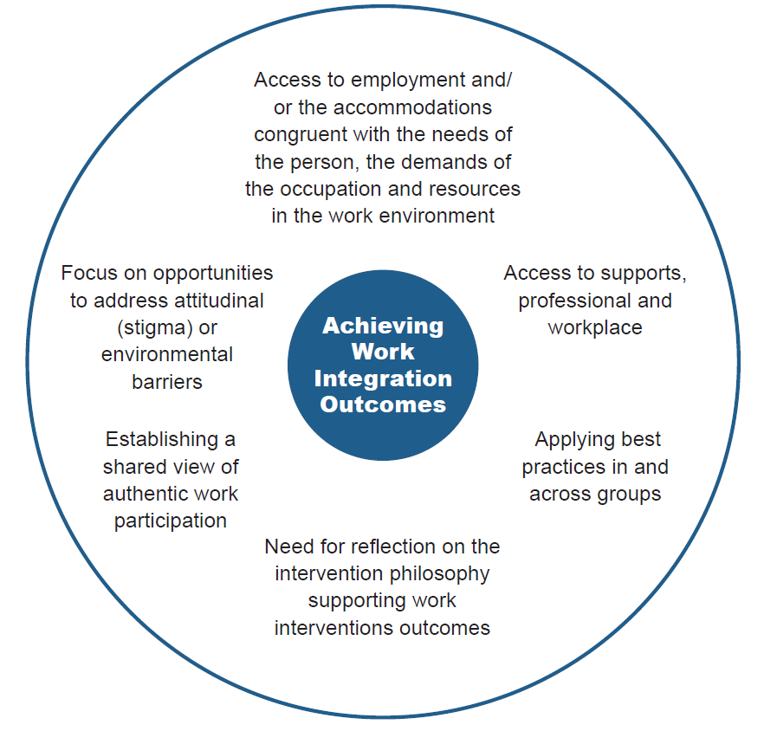

Appendix 2 –

Promising Service Delivery Practices - Summarised and tabulated from: Promising service delivery practices that lead to employment in vocational rehabilitation: Valle et al (2014)

Promising Practice | Their example | Result | Working Group
Contracting with another agency to provide ‘non-core functions | Another agency contracted to do the admin tasks leaving the VR to focus on the ‘core’ employment tasks with eligible people | Led to increase in service responsiveness | No experiences of this
Certification of the program | Staff had to meet basic training (e.g. job coach) delivered on-line | Some providers refused and left % others stepped in. Resulted in better services | Could see the sense of this
Manage business relations and assist staff to bring job-ready consumers and employers together | Web-based cloud technology DARSforce |  | Could see the attraction but couldn’t locate DARSforce’s existence now (on google)
Building the capacity/ productivity of employees over time | Embedded Training Programs (ETP’s) | Removes burden of training or making work adjustments from employers | Not heard of ETP’s
Less specialized supports for people who wouldn’t qualify for intensive services but who cannot find a job | Choose to Work program Utah | Not provided but good website where you can see the program https://www.usor.utah.gov/home-vocationalrehabilitationservices/choose-towork-ticket-to-work | Makes sense to fit supports to people’s needs

Promising Practice | Their example | Result | Working Group
Benefits counselling/ planning services | Maryland partnership between their benefits counselling service and Department of Disabilities | People can go back to work with more confidence and staff gain knowledge too – more informed to choose best vocational goal | Yes, really important as this is what puts people/families off trying to find work as they fear being worse off and unable to get benefits back if things don’t work out. Relationship with liaison person at Work and Income crucial
Soft skills training | Smart Work Ethics standardized curriculum to change behavior and improve employability through interactive training | Found in Mississippi to help people to be more employable with demonstrably better communication, punctuality, time management, appropriate grooming etc. | Agreed this is an important area and people with client group knowledge/ skills
Belief that everyone can work | Maryland Seamless Transition Collaborative for all disabled students | Much better outcomes | Agreed by everyone
Partnering with specialist agencies that best meet client need | Extending support to people with Traumatic Brain Injury postemployment | Employment retained for longer periods | As directed and chosen by the person
Integrating health and employment services | The Individual Placement and Support approach | Single point of entry, facilitates consumer choice | Agreed by everyone but not happening

Appendix 3 –

Promising Organisational Practices summarised and tabulated from: Promising organisational practices that lead to employment in vocational rehabilitation: Del Valle et al (2014)

Promising Practice | Their example | Result | Working Group
Promoting innovation | Incubator unit Try new things without formal permission but share results | Positive change at multiple levels Staff motivated to take risks Leadership encouraged to catch people doing something right, understand that and communicate it | Agreed
Sharing best practice | Web-based central site to share ideas (brag & steal) | Pride taken in sharing success and post new ideas | Agreed
Changing attitudes | E3 – Excellent service, every consumer, every time | Approach strongly endorsed by leaders | Agreed
Employer relations | Employer relations team | Building relationships and trust – the businesses keep coming back | Agreed but acknowledged difficult to resource
Strong business model | Strong working relationships with legislators, employers, partner agencies and the public | “constituents have a better understanding of program connectedness and benefits to both the disability and business communities” | Yes but this is currently a challenge – “providers running on the smell of an oily rag”

Promising Practice | Their example | Result | Working Group
Rapid response and internal service delivery | Benefits counselling, job placement and on-the-job supports provided internally | Saved resources by providing services internally where possible Specialist service for most disabled exclusively to VR customers
Specialist staff | Specialised caseloads with staff skilled with each group | Not provided but seen as positive | Agreed and that caseloads needed to be adjusted accordingly
Data driven | Investment in monitoring outcomes then can show success to all stakeholders. | (USOR) developed its own list of high quality indicators for job placements etc. | Agreed
Organisational skills enhancement | Succession planning for future leadership roles | Transformation of agency culture e.g. from case management to client centred, holistic approach | Agreed

Appendix 4 –

Bibliography
- Bond, G. R., Drake, R. E., Becker, D. R. (2012). Generalizability of the Individual Placement and Support (IPS) model of supported employment outside the US. World Psychiatry 2012:11:32-39
- Cohen, M. J., & Becker, D. R. (2014). Family advocacy for the IPS supported employment project: Accomplishments and challenges. Psychiatric rehabilitation journal, 37(2), 148.
- Chow, C. M., Cichocki, B., & Croft, B. (2014). The impact of job accommodations on employment outcomes among individuals with psychiatric disabilities. Psychiatric Services, 65(9), 1126-1132.
- Del Valle, R., Leahy, M. J., Sherman, S., Anderson, C. A., Tansey, T., & Schoen, B. (2014). Promising best practices that lead to employment in vocational rehabilitation: Findings from a four-state multiple case study. Journal of Vocational Rehabilitation 41 (2014) 99-113.
- Donelly, M., & Given, F. (2010). Employment programs and professionals with a disability. Work, 36(2), 217-225.
- Fadyl, J.K., & McPherson, K. M. (2009). Approaches to Vocational Rehabilitation After Traumatic Brain Injury: A Review of the Evidence. J Head Trauma Rehabilitation, Vol. 24, No.3, pp 195 – 212.
- Fadyl, J., McPherson, K., & Nicholls, D. (2015). Re/creating entrepreneurs of the self: discourses of worker and employee ‘value’ and current vocational rehabilitation practices. Sociology of health & illness, Vol. 37. No. 4 2015 ISSN 0141-9889, pp. 506-521.
- Gussenhoven, A. H., Jansma, E. P., Goverts, S. T., Festen, J. M., Anema, J. R., & Kramer, S. E. (2013). Vocational rehabilitation services for people with hearing difficulties: A systematic review of the literature. Work, 46(2), 151-164.
- Hedley, D., Uljarević, M., Cameron, L., Halder, S., Richdale, A., & Dissanayake, C. (2016). Employment programmes and interventions targeting adults with autism spectrum disorder: A systematic review of the literature. Autism, 1362361316661855.
- Kirsh, B., Stergiou-Kita, M., Gewurtz, R., Dawson, D., Krupa, T., Lysaght, R., & Shaw, L. (2009). From margins to mainstream: what do we know about work integration for persons with brain injury, mental illness and intellectual disability?. Work, 32(4), 391-405.

- Krysta, J., Krysta, K., Zawada, K., Cubała, W. J., Wiglusz, M. S., & Jakuszkowiak-Wojten, K. (2015). Development of vocational training systems for patients with intellectual disability in Poland. Psychiatria Danubina, 27, 401-407.
- Kramer, S. (2008). Hearing impairment, work, and vocational enablement. International Journal of Audiology (2008); 47 (suppl 2): S124-S130.
- Leahy, M. J., Chan, F., & Lui, J. (2014). Evidence-based Best Practices in the public Vocational Rehabilitation Program that Lead to Employment Outcomes. Journal of Vocational Rehabilitation 41 (2014) 83-86.
- Leahy, M.J., Chan, F., Lui, J., Rosenthal, D., Tansey, T., Wehman, P., Kundu, M., Dutta, A., Anderson, C. A., Del Valle, R., Sherman, S., & Menz, F. E. (2014). An analysis of evidence-based practices in the public vocational rehabilitation program: Gaps, future directions, and recommended steps to move forward. Journal of Vocational Rehabilitation 41 (2014) 147-163.
- Lord, S.E., & McKurk, S. R. (2014). The Potential of Technology for Enhancing Individual Placement and Support Supported Employment. Psychiatric Rehabilitation Journal 2014, Vol 37, No. 2, 99-106.
- Marshall, T., Goldberg, R. W., Braude, L. Dougherty, R. H., Daniels, A. S., Ghose, S. S., George, P., & Delphin-Rittmon, M. E. (2014). Supported Employment: Assessing the Evidence. Psychiatric Services ps.psychiatryonline.org January 2014 Vol. 65 No. 1.
- Mills, A. L., & Kreutzer, J. S. (2015) Theoretical Applications of Positive Psychology to Vocational Rehabilitation After Traumatic Brain Injury. Journal of Occupational Rehabilitation (2016) 26:20-31. DOI 10.1007/s10926-01509608-z. • Modini, M., Tan, L., Brinchmann, B., Wang, M-J., Killackey, E., Glozier, N., Mykletun, A. & Harvey, S. B. (2016). Supported employment for people with severe mental illness: a systematic review and meta-analysis of the international evidence. The British Journal of Psychiatry (2016) 209, 14-22. Doi: 10.1192/bjp. bp.115.165092.
- Mueser, K.T., & Drake, R.E., & Bond, G.R. (2016). Recent advances in supported employment for people with serious mental illness: A review of IPS. Current opinion in Psychiatry (2016) 29: 196-201.DOI: 10.1097/yco 0000000000000247.
- Mueser, K. T., & McGurk, S. R. (2014). Supported employment for persons with serious mental illness: current status and future directions. L’Encéphale, 40, S45-S56.
- Nicholas, D. B., Attridge, M., Zwaigenbaum, L., & Clarke, M. (2014). Vocational support approaches in autism spectrum disorder: A synthesis review of the literature. Autism, 1362361313516548.

- Poremski, D., Whitley, R., & Latimer, E. (2016). Building trust with people receiving supported employment and housing first services. Psychiatric rehabilitation journal, 39(1), 20.
- Roels, E. H. Aertgeerts, B. Ramaekers, D. & Peers, K. (2016). Hospital and community-based interventions enhancing (re) employment for people with spinal cord injury: a systematic review. Spinal Cord (2016) 54, 2-7.
- Sherman, S. G., Leahy, M, J., Del Valle, R., Anderson, C. A., Tansey, T. N., & Lui, K. (2014). Organizational and cultural factors that promote best practices in the public rehabilitation program: findings from a four-state multiple case study. Journal of Vocational Rehabilitation 41 (2014) 115 – 125.
- Trenaman, L. M., Miller, W. C., & Escorpizo, R. (2014). Interventions for improving employment outcomes among individuals with spinal cord injury: a systematic review. Spinal cord, 52(11), 788-794.
- Waghorn, G. & Hielscher, E. The availability of evidence-based practices in supported employment for Australians with severe and persistent mental illness. (2014). Australian Occupational Therapy Journal (2015) 62, 141-144.
- Wehman, P. (2012). Supported Employment: What is it? Journal of Vocational Rehabilitation 37 (2012) 139-142.
- Wehman, P. H., Schall, C. M., McDonough, J., Kregel, J., Brooke, V., Molinelli, A., ... & Thiss, W. (2014). Competitive employment for youth with autism spectrum disorders: Early results from a randomized clinical trial. Journal of autism and developmental disorders, 44(3), 487-500.
- West, M., Targett, P., Wehman, P., Cifu, G., & Davis, J. (2015). Separation from supported employment: a retrospective chart review study. Disability and rehabilitation, 37(12), 1055-1059.

Appendix 5 –

Features of regulation and policy that would provide the best conditions for employment support services for disabled persons as identified from the evidence review.

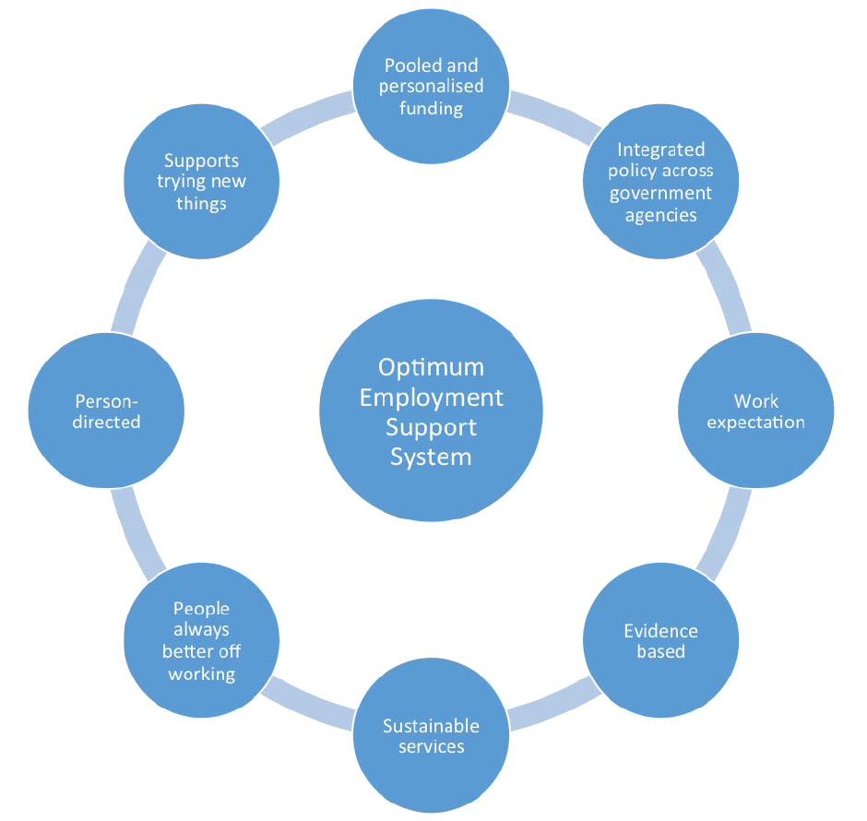

Appendix 6 –

Significant barriers to success in current regulation and policy (identified by stakeholders)

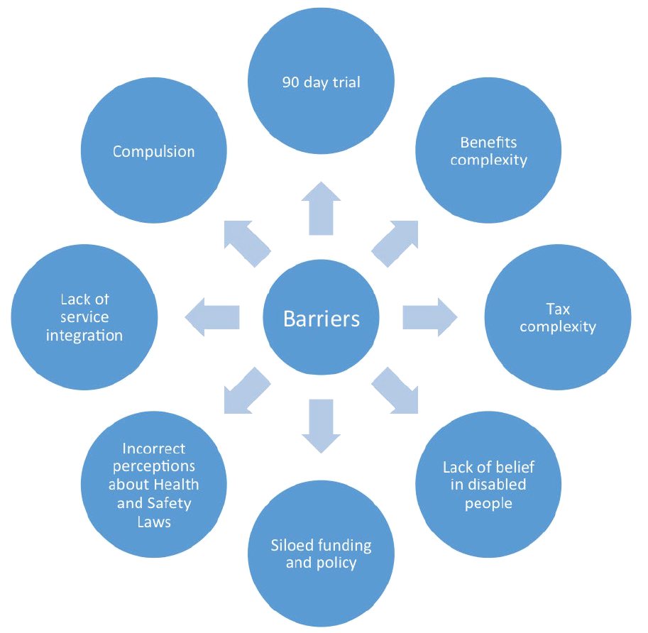

Appendix 7 –

Significant enablers to success (identified by stakeholders)

