Enabling Good Lives Sooner Rather Than Later

WHERE TO FROM HERE?

A Sector Briefing from NZDSN
The New Zealand Disability Support Network 2020

Leading and influencing Change that supports Inclusive Lives

About us

Leading and influencing change that supports inclusive lives for disabled people
NZDSN is a national network of over 160 organisations that provide support services to disabled people, mainly through contracts with government. We are governed by an elected Board from the wider membership and employ a full time Chief Executive with a small staff team mostly based in Wellington.

Our focus is leading and influencing change that supports inclusive lives for disabled people. We provide a strong voice and policy advice to government on behalf of our members and facilitate innovation and quality with providers.

The NZDSN Sector Briefing is a regular report to the sector in which we outline:

- issues and concerns that are significantly impacting service providers and the lives of disabled people and families
- recommendations to government for addressing these matters, and
- NZDSN’s own commitments and activities to support change.
This 2020 Sector Briefing has a firm focus on the 2020 Budget and the general election that follows later in the year.

| 2

Contents
The New Zealand Disability Support Network 2020

About us 2
Dashboard summary 4
Introduction 6
The value of effective support services 9
How big is the problem? 14
What are the solutions? 16
Three immediate solutions 17
Three medium term solutions 21
Appendix : The Enabling Good Lives Principles 24

A Sector Briefing from NZDSN | 3

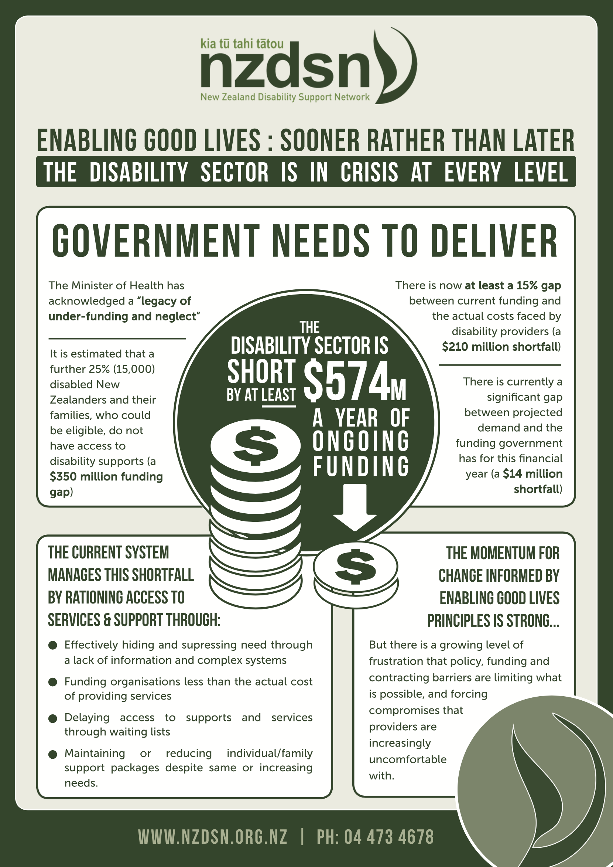
R THAN LATE
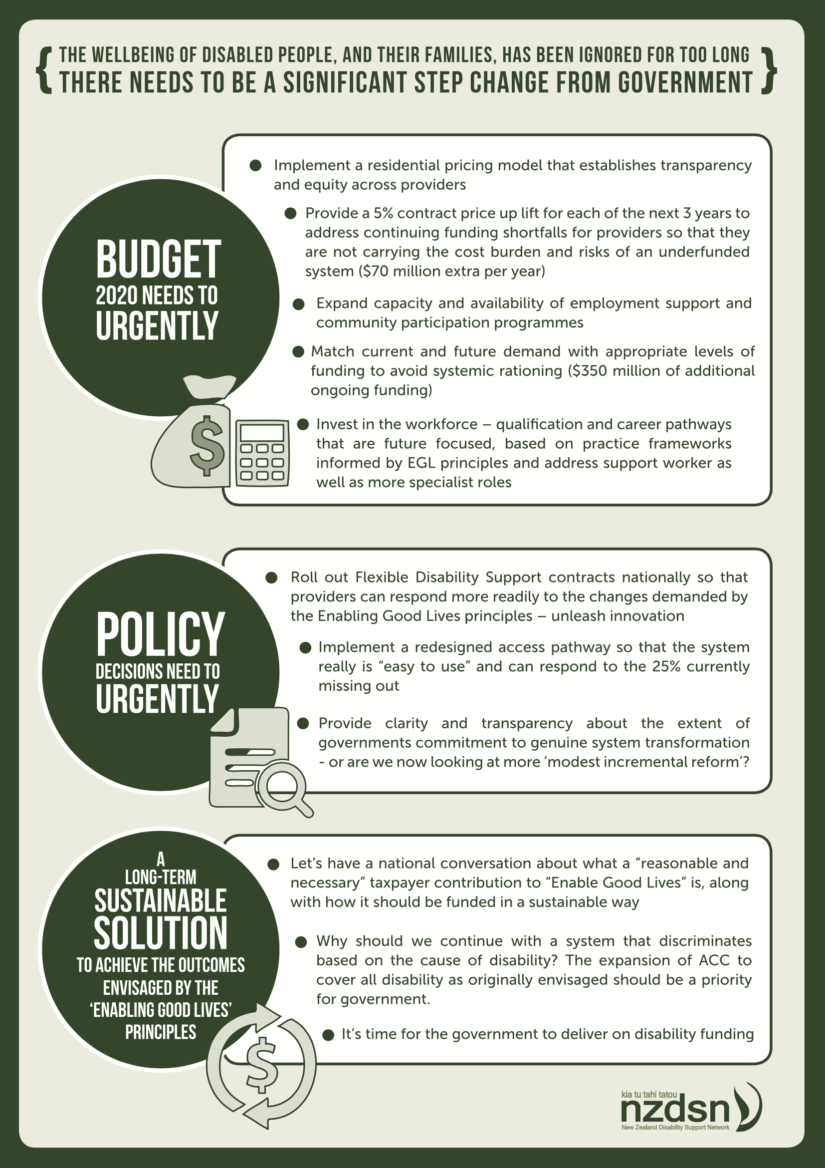

Introduction

The last year has seen some emerging uncertainty about the prospects of System Transformation as a national roll out of a
completely re-designed disability service
system informed by the Enabling Good Lives
(EGL) principles. It is clear from earlier cabinet papers and official advice that Enabling Good Lives and System Transformation have always
been regarded by officials as a strategy for cost containment and a means of avoiding more
fundamental (and expensive) reforms.
“

The issues have been bubbling away for many years. If they boil over, we may over-correct to a much more expensive demand driven system such as Australia’s national disability insurance scheme or an expansion of the accident compensation scheme.1

- Aide Memoire T2017/160 Enabling Good Lives Meeting with Minister p.1. 2017

| 6

The New Zealand Disability Support Network 2020

The idea that we would not want a demand led system like ACC is ironic.
It’s exactly what we need. Governments appetite for such a bold and just solution needs to be developed in order to redress the systemic discrimination currently experienced by people in the Health and MSD funded disability system.

It is time for the Government to deliver.
Government now appears to be grappling with the expectations generated by the prospect of a transformed system, a continuing imperative to contain costs in the current system and emerging evidence that implementation
of EGL informed changes will likely add significantly to costs. There is an increasing likelihood that while there may be changes that could increase flexibility, choice and control by disabled people and their families it will be exercised over the same or even diminishing resources. We thus end up with a high level of dissonance between the rhetoric of ‘choice, control and flexibility’ on the one hand and ‘cost control and cost reductions’ on
the other.

Not surprisingly a more accessible and flexible system generates more demand and expectation.
Both from people who had not previously accessed support and from people already in the system. If this is occurring in the context of continuing requirements to contain or even ‘turn the curve’ on government spending, then ‘enabling good lives’ will remain over the horizon for a significant proportion of disabled people and their families – even though they might have more flexibility, choice and control over the resources they do have.
A cruel irony indeed. For organisations providing disability support services in such an environment there is an ongoing challenge: responding to
the demand for EGL informed changes to practice, but in the face of a diminishing ability to invest in the innovation required.

A Sector Briefing from NZDSN | 7

There is no doubt the current system poses many barriers to realising
the outcomes envisaged by the EGL principles.
The idea that these outcomes could be realised without any ongoing increase in investment to make and then sustain the changes required is disingenuous. To talk of ‘transformation’ in this context is very misleading. In a recent speech to a Ministry of Health Forum the Minister acknowledged that we have:
“

A health and disability system that has been woefully underfunded and neglected.2
“
He went on to say that

The reality is that we have avoidable, unfair and unjust differences in health and wellbeing outcomes for some people, particularly Maori and Pacific peoples, people living in poverty and people living rurally.3
Concerningly, the Minister neglected to explicitly include disabled people and their families.

- & 3 Speech to Ministry of Health Forum
by Hon. Dr David Clark 29 October 2019

| 8

The disability sector is in crisis at every level and the wellbeing of disabled people and their families has been ignored for far too long. A step change in the Government’s response to the sector is long overdue.
The combined Ministry of Health (DSS) and Ministry of Social Development (MSD) spend on disability support services is approximately
$1.4 billion and this supports around 60,000 disabled people and their families. The last budget saw the first significant increase in funding in a decade of $76 million.
That’s a start, but to truly deliver on the Prime Minister’s promise of a
Government that brings back kindness and looks after all New Zealanders, much more is needed in Budget
2020 and beyond. With Government running large surpluses and having met its debt targets, the time is right to invest in better lives for disabled New Zealanders

The value of
The New Zealand Disability Support Network 2020

effective support services

The EGL principles articulate a set of ideas
and a message for change that has been building for a generation. Over the past four years NZDSN has resolutely committed itself to supporting the implementation of EGL informed change by providers.
We have hosted hundreds of training and networking events involving thousands of people, partnered with the EGL Leadership Group to introduce EGL Communities of Practice, ensured EGL has been a central theme at our annual conferences, worked to improve the relevance of qualifications and contributed to dozens of reference groups and working parties.

The momentum for transformational change is strong amongst providers. Most organisations are now actively incorporating EGL principles into the way they think and practice and many have embarked on organisational change and renewal to support these efforts. There is now a developing capability and capacity to partner with disabled people and families to facilitate and support the outcomes envisaged by EGL. But there is a growing level of frustration that policy, funding and contracting barriers are still limiting what is possible and forcing compromises that providers are increasingly uncomfortable with.

The focus of this Sector Briefing is to describe how providers are experiencing the current system and the consequences for disabled people and their families. We then outline what needs to happen so that the contribution and value of providers to EGL implementation can be maximised, not impeded. In doing so we offer recommendations for Government that can support us to invest, to be flexible and to enable good lives.

A Sector Briefing from NZDSN | 9

Experiencing the current system

Suppressing and hiding need – active rationing
Whether by design or default the current disability support system has become very effective at hiding and suppressing need over several decades and no doubt lowering the expectations that disabled people and families should have of the system. While government talks about ‘managing access to services
and supports’ we should name this for what it actually is – the active rationing of access to support and services. This rationing acts
to both keep eligible people out of the system altogether and to minimise the allocation of supports and services to those lucky enough to be in the system. While there are complex systems in place to identify peoples ‘needs’ these are inevitably re-defined in terms of the resource available. This pattern continues when determining pricing for providers – not
based on the actual cost of delivery, but reverse engineered to fit a pre-determined budget.

What is reasonable and necessary?
The result is people with allocations that only partially meet their actual needs and pricing for providers that only partially matches their actual costs.
What has always been missing in this context is an honest, transparent and sector wide discussion of what a reasonable and necessary contribution from the tax payer should be to ‘enable good lives.’ In the absence of this conversation we end up in endlessly circular arguments about assessed need, resourcing
and pricing because the dialogue is not founded
on any consensus about what is ‘reasonable and necessary.’ The consequences for disabled people, families, providers and funders are experienced as a cycle of unmet need, access barriers, disagreements about resourcing and
dashed expectations.

A further 25% or 15,000 New Zealanders with disability don’t
have access

The EGL demonstrations in Christchurch and the Waikato and now the System Transformation Prototype in Mid Central have all consistently experienced the emergence of approximately another 25% of people previously unknown
to the system, but clearly eligible for services. There is mounting evidence to suggest that a further 25% of New Zealanders with disability and their families have no access to support that they are actually eligible for. This is another 15,000 people. Moreover, this group are reported to be disproportionately Maori, Pacific
peoples, rural and poor. The system seems to be very effectively maintaining barriers that make
it difficult to know about and/or access support. It is also not difficult to conclude that getting access to the system, and getting what one needs from it, relies to at least some extent on having a degree of “social capital” – information, access to advocacy, influence, resources, time and connections.

| 10

The New Zealand Disability Support Network 2020

This is not fair or equitable and is highly discriminatory. It is also completely at odds with the current Government’s commitments to the wellbeing of all New Zealanders

How rationing works
Once connected and in the system, there seem to be four basic ‘business as usual’ strategies used to ration individuals support packages and the funding allocations that accompany these:
- Delay the referral and keep the person on a waitlist – hopefully until the new financial year. This is frequently the case for people needing assistive equipment, technology, housing modifications and for higher cost service lines like residential services.
These delays can significantly contribute to situations where the person/family is likely to end up in crisis and/or exacerbate the individual’s impairment – and frequently add cost by the time the person does get access to support. Definitely a false economy.
- A new referral is forwarded to a provider where the allocated funding is clearly short of what it will cost to provide the service. The provider is faced with some very difficult choices:

Say no to the referral and:
  - bear the financial cost of holding open a possible vacancy and/or
  - risk being in breach of contract with pressure from the funder to accept and/or
  - endure the ethical dilemma of knowingly being party to maintaining ongoing unmet need for an individual and/or family
Say yes to the referral knowing that the maths does not add up - further stretching resources and exacerbating the financial strain on the organisation – and ultimately contributing to compromised safety and quality
- An assessment review for an existing person/family leaves the resource allocation unchanged despite increasing need
Leading to further financial challenges for the provider and/or the dilemmas associated with saying no (and possibly exiting the person from the service).
- An assessment review for an existing person/family reduces the resource allocation despite the same or increasing need.
Leading to further financial strain for the provider and/or the dilemmas associated with saying no (and possibly exiting the person from the service). A variant on this approach is reduced funding on the basis that the person is now living a more independent
life without recognising that maintaining this outcome can depend on retaining the current level of funding.

These four sets of circumstances are more likely to occur for people with higher or more complex needs where the possibility of urgency or the prospect of the person or family being in crisis is higher. It also means that funding discrepancies involved can be in the thousands of dollars, rather than hundreds.

A Sector Briefing from NZDSN | 11

Juggling competing imperatives
While providers are increasingly considering declining referrals and in some cases have pursued this they are still saying yes in most circumstances. Organisations providing disability
Our solutions balanced the need for privacy and individualised support with appropriate staff support models and housing configurations.
Alas, this would require some investment and we are not aware of any further progress.

support services are strongly values based and readily recognise the ethics and consequences

for the people they exist to serve when considering whether or not to accept referrals or to exit people from services. However, providers are increasingly caught between a ‘rock and hard place’ as they juggle the competing imperatives of providing services on the one and financial survival on the other. Boards are increasingly putting pressure on organisations by reminding them of their responsibilities and duties with respect to maintaining quality, safety, and financial solvency – all of which now carry increased legal oversite and compliance costs.

This juggling act is more acutely felt when the circumstance involves people with very complex needs. In this context the stakes are far higher
– financially as well as the ability to manage the risks around quality and safety. The governing boards of providers are becoming increasingly strident about the need to manage these financial, quality and safety risks in a sustainable manner, especially in the absence of any shared risk between funder and provider. Many of the people in these circumstances cannot always live with others which can add exponentially
to costs.

NZDSN and several of our members offered design and property solutions to an ROI request over two years ago for people with complex needs in crisis.

There is a $14 million gap between current demand and government funding for this financial year

The rationing strategies identified above are unlikely to dissipate any time soon. Although the last budget delivered significant increases to meet demand pressures on the system the
$76 million funding made available was still approximately $14 million less than what was actually spent in the previous financial year. If demand remains at similar levels or increases (which is likely) the prospect of continuing and even increased rationing is high.

Furthermore, the budget delivered a nil contract price increase for DSS providers for the second year in a row. In addition, Government has an:
“

Expectation that providers absorb cost increases through efficiencies and operational structural reorganisation. 4

4 Disability Directorate NDE financial sustainability plan presentation to DG October 2018

| 12

ThTeheNNewewZZeeaalalannddDDisisaabbiliiltityy SSuuppppoorrtt NNeettwwoorrkk 22002200

Providers have been getting more efficient for several years as the gap between funding and actual costs accelerates. Finding efficiencies as a continuing cost saving measure eventually has consequences for quality and safety, never mind the capacity to invest in the innovation being demanded by EGL.

The funding gap for providers is now 15%

Leading up to the last budget NZDSN estimated that the overall gap between funding and the cost of services was approximately 12% (partly informed by the report commissioned from Deloittes). With the absence of a contract price increase and another round of impacts from the pay equity settlement a further 3% on average has been added to provider costs. That’s now
a 15% gap, or $210 million. That government is relying on providers to fill this gap by finding yet further “efficiencies” is a fantasy and
actually irresponsible. Such an approach poses significant risks for growing waitlists, growing levels of unmet need, reduced services and the possible withdrawal from contracts for whole programmes by some providers.
These risks are not being shared by funders and providers. Providers are in effect being left to prop up a broken system that is tipping into crisis.

An example of an actual crisis is the perilous state of MSD funded Community Participation Programmes.
These are programmes that are supposed to have a central role in supporting disabled people to participate in everyday activities and every day places in their communities.
Although the last budget delivered a small increase in funding, this was the first in over a decade and with government acknowledging that these programmes are now only funded for around 50% of actual costs. Over time providers have steadily reduced the numbers being served to keep financially afloat. The consequences are that rapidly increasing numbers of disabled people have no or only partial access to programmes, family members are having to give up their own jobs to provide support and residential and supported living providers are filling the gap (without any funding) when people in these services cannot access programmes. It is also becoming increasingly difficult to provide personalised approaches in line with EGL principles with many continuing to maintain centre and group based programmes.

Ironically, earlier budget bids for community participation
programmes have been knocked back on the basis that EGL informed change was supposed to be reducing the cost of support. 51

5 Aide Memoire T2017/160 Enabling Good Lives Meeting with Minister p. 3. 2017

A Sector Briefing from NZDSN | 13

How big is the problem?

The combined DSS and MSD spend on disability support services is approximately $1.4 billion
and supports around 60,000 disabled people and their families. It is important to remember that
this is separate from the funding made available to implement the pay equity legislation for
support workers.
This funding simply enables employers to
meet their obligations to pay the new minimum pay rates required under the legislation. It is
essentially “money in/money out” and does not improve the financial position of organisations. In fact, the flow on impacts and wage relativity costs create a significantly increased financial
burden for providers and are a major contributor to the 15% gap between actual costs and current funding provided in contracts.

| 14

The New Zealand Disability Support Network 2020

To summarise then:
The combined DSS and MSD spend on disability support
services is currently approximately
$1.4 billion
15,000 disabled people and their families are not getting access to support they are entitled to. Local demonstrations and pilots show that on top of people already receiving support, there
is an additional 25% of disabled New Zealanders and their families who don’t currently access the
system. That’s another 15,000 people nationwide. $350m shortfall (and only based on current funding levels).
There is a 15% gap between the actual costs of providing
current services and the contract
prices paid to providers.
A $210m shortfall
There is a gap between current demand and the funding allocated in this year’s budget.
A $14m shortfall

$574m needed
more per year to be spent on the disability support system.

Shouldn’t we just apply current policy settings more consistently?
There appears to be belief that more consistent application of long standing policy and eligibility settings across the system will result in significant savings. This assumes that there are significant numbers of people drawing larger allocations or resource packages than they actually need. This is very unlikely. While there may be some people drawing larger packages than others with similar need it is more likely that they are in fact getting what they need and others are not.

We know that people who can draw on a reservoir of social capital get more out of the system than those who do not.
Any approach that relies on ‘national consistency’ is likely to simply result in more consistent rationing of the existing resource – everyone would then be more equally under resourced.
This approach is unlikely to deliver any significant savings.

What is missing is a genuine focus on developing a national consensus on the expectations that people should be able to have of a disability support system and a cost-effective strategy for funding this in a way that enables those expectations to be actually realised.
We cannot continue to frame the discussion within current resources as this funding has never been systematically linked to the outcomes we want to achieve.

A Sector Briefing from NZDSN | 15

What are the solutions?

Clearly major investment is needed to address the multiple shortfalls and inequities that
are experience by disabled people, families and providers. And we need to make a start.
NZDSN’s view is that there are three
immediate steps that need to be taken urgently as part of budget 2020
(one of which can be implemented with limited financial impact).
Then there are three medium term solutions that need a bit more work and will take longer to implement, but a start can still be made with budget 2020. We also acknowledge that
work is already underway on some of these latter aspects as part of the System Transformation
work programme.

| 16

The New Zealand Disability Support Network 2020

Three Immediate Solutions
1

Implement a Transparent Residential Pricing Model (RPM)
This has been in development for almost a decade (probably at considerable cost). Failure to implement it has perpetuated significant inequities across residential providers for many years. It is imperative that these are addressed before any across the board changes to pricing or commissioning of services. Residential services provide 24hr support for over 7,000 individuals largely through small “group homes” of between
4-6 residents although there are a small number of larger facilities. There is growing momentum for more individualised approaches informed by EGL principles so it is important that there is an equitable funding base to support such changes.

NZDSN and a small working group have already invested significant time and effort in working with the Ministry of Health to land a transparent residential pricing model (RPM). Implementation failure has been
based on a lack of acknowledgement and understanding of business realities for providers and the actual costs involved. The consequence has been proposed models that have been reversed engineered to fit a pre-determined budget. The result is the possibility that while some
providers would get funding increases some may get funding decreases. A “robbing Peter to pay Paul” approach is not acceptable as it assumes some providers are “over funded” and should get funding cuts. There is no evidence to support this in a sector that has a legacy of neglect and
underfunding. NZDSN would, as a first step, accept a model that has some providers with funding increases and some without increases. Beyond such a first step there would clearly need to be further work to ensure a fully sustainable, fair and transparent pricing model across all providers and particularly with those who may initially miss out on funding increases.

A Sector Briefing from NZDSN | 17

Make a start on addressing immediate pricing shortfalls with a 5% contract price uplift for each of the next 3 years across all MoH and MSD funded providers
2

These increases are needed to address the accelerating gap between current funding and the actual cost of providing services. This gap has been added to as the result of a second year in a row of nil contract price increases and another round of pay equity impacts because of the failure to acknowledge pay relativity issues. There have also been important legislative changes to improve working conditions in the sector,
but which have added costs for providers:

- The implementation of the sleepover legislation
- The implementation of pay equity legislation
- Numerous amendments to employment and health and safety legislation On top of this costs are being driven up by:
- Failure to implement a residential pricing model
- Rationing of individual support packages that do not account for actual need and costs
- Collective agreements that extend terms and conditions
While both the Ministry of Health and the Ministry of Social Development have acknowledged that there are funding shortfalls there is the already observed expectation that providers absorb price increases faced through efficiencies and operational structural reorganisation. Such a position is profoundly out of step with the reality for providers and fails to acknowledge that finding efficiencies has been business as usual for some time. It also disregards any sense of shared risk in terms of the consequences of such an approach for the safety and quality of services. It demonstrates a lack of understanding of contemporary governance accountabilities in relation to financial as well as health and safety risks. And finally it fails to acknowledge the active
rationing strategies that are used to hide need, delay access to support and then systematically under resource individuals, families, and organisations that provide services.

| 18

The New Zealand Disability Support Network 2020

In stark contrast most providers describe a very different experience with other funders such as Oranga Tamariki, Corrections and ACC. Relationships here are characterised by a partnership approach where managing risks are a shared endeavour and where negotiations around costs are based on a high trust model that assumes providers know
their business.

There is now a rising tide of disappointment, frustration and impatience about the lack of progress government is making on key funding issues.
There is a growing trend for providers to refuse referrals or exit from those circumstances where “the maths does not add up” and the risks are too great to bear from a safety, quality and financial perspective.
The prospect of some providers having to exit whole programmes is becoming inevitable. Community Participation programmes are a case in point given that government already recognises that they are only contributing 50% of the actual costs.

It is not acceptable that providers are having to face the dilemma of whether they take on the next referral knowing that the funding being offered will not meet the costs involved – and that if they do accept the referral they further undermine the quality and safety of services along with the organisations financial sustainability.

A Sector Briefing from NZDSN | 19

Implement Flexible Disability Supports (FDS) Contracts nationally
3

There is an urgent need to increase the flexibility of the system so that disabled people and families can directly negotiate with providers the specific supports and services they want. Such a negotiation needs to be informed by an indicative budget so that both parties know what funding they are dealing with. Flexible Disability Supports (FDS) contracts are an approach that enables providers to engage with anyone who wants to access a personal budget – for people new to the system as well as those already receiving support from a provider.

Even in the absence of any increased funding, FDS contracts provide an opportunity to respond more flexibly and demonstrate the implementation of Enabling Good Lives in practice through an individualised approach.
It also requires everyone to focus on the outcomes people want and to have funders and providers focused on ensuring that these are realised. FDS contracts are the opportunity for the funder to shift from the rhetoric of ‘commissioning for outcomes’ to doing so in practice.

Even in the current resource constrained environment, FDS has the potential to unleash the creativity and innovation we know many providers are capable of. FDS removes the constraints of restrictive service specifications and dispenses with multiple service lines and funding buckets like residential services, supported independent living, choices
in community, community participation and Individualised Funding (IF) options. Such an approach is also consistent with flexible support for families such as I Choose (respite care) and Funded Family Care which are also awaiting implementation.

FDS requires providers to closely examine their practices, approaches and costs in relation to more personalised approaches to support.
FDS contracts are currently only available in Christchurch and Mid Central. There is no reason why they cannot be rolled out nationally. NZDSN is ready to assist in any way it can to help facilitate a national roll out.

| 20

The New Zealand Disability Support Network 2020

Three Medium term solutions for a sustainable sector that enables good lives

1 A Sustainable Funding Approach
At present, discussions about appropriate funding are always framed within the context of the current resourcing available – a resource that has developed over many years in an ad hoc fashion with no reference to actual need and costs. We need a programme of work that seeks to develop
a sustainable funding approach that can effectively contribute to the outcomes envisaged by the Enabling Good Lives principles. This needs to include cross sector consensus on what a reasonable and necessary tax payer contribution via the disability support system is. Such a programme of work needs to:
- Balance the current goal of “controlling expenditure as the highest priority”
with the need for obvious investment to deliver on the Enabling Good Lives principles
- Provide clarity and transparency about the extent of governments commitment to genuine system transformation - or are we now looking at ‘modest incremental reform’?
To what extent will the Machinery of Government Review provide some clarity?
- Develop funding models that are based on the actual costs of an efficient provider and that offer disabled people and families personal budgets with purchasing power that does not compromise EGL principles.
- Recognise that we currently have a system that systematically discriminates on the basis of the cause of disability with huge differences in support between the health/disability and ACC systems. The appetite for an expanded ACC system as originally envisaged is growing – what is government’s position on this?
- Reference and align with the Disability Action Plan commitments to addressing mainstream access to housing, employment, transport, education and health services along with the Governments obligations under the UN Convention on the Rights of Persons with disabilities.
- Implement nationally a redesigned access pathway as envisaged by the initial high level prototype design so that the system really is “easy to use,” can respond to the 25% currently missing out and uses a practice framework informed by Enabling Good Lives principles

A Sector Briefing from NZDSN | 21

2 An Investment plan for the Workforce
The sector needs a workforce that has ready access to qualification and career pathways with content that has a focus on practice frameworks informed by EGL principles. They need to be readily available to all support workers (early in their employment) whether they are employed by individuals, families, small or large providers – and delivered to a consistently high standard in every setting. We also need diploma level qualifications that support specialist roles in areas like employment support, connector/tuhono roles, behaviour support, advocacy/supported decision making and other practice leadership roles.

We are a very long way from this scenario at present with variable quality and access spread across multiple employers and training providers. We also have a huge amount of one-off training through courses, seminars and workshops that is available from multiple sources across the sector
– none of which is linked to any qualification – and is also of variable quality. Funding to support this training activity is highly contestable and is a long way from meeting demand. Too much reliance on this approach to workforce development in a sector with high staff turnover is self-defeating.

NZDSN has consistently advocated for approaches that address these issues and delivers qualifications that are future focused, support the implementation of EGL in practice, are accessible to all and delivered to a consistently high quality. We are currently leading projects that explore a collaborative “partner employer” approach and are also coordinating the development of relevant content and delivery for a diploma qualification in employment support.

However, there needs to be systematic intent and an investment plan to realise the real benefits of an appropriately qualified workforce. The
reforms to vocational education seek to address some of the shortcomings of the current approach. NZDSN will be seeking to shepherd current projects through the reform process with a view to expansion through the new Workforce Development Council model.

The pay equity settlement was intended to link remuneration and qualifications to create a more productive workforce. This will be a missed opportunity if we don’t systematically invest in high quality future focused qualification and career pathways.

| 22

The New Zealand Disability Support Network 2020

3 Invest to improve employment outcomes for disabled people
Employment is central to achieving a measure of financial security along with achieving wider health
and well-being outcomes. Employment participation rates for disabled people in New Zealand are less than half than the non-disabled population and they have not moved significantly for a generation. The two largest groups of unemployed disabled people are those with significant
intellectual or learning disabilities and those with significant mental health conditions. They also tend to be the people most at risk of being left behind when it comes to accessing employment initiatives and support services. This is due both to misplaced stereotypes about who is ready and capable
of employment and to the institutionalised discrimination at work in the way employment support services are funded and contracted. Policy settings in this context have been driven by a desire to reduce the numbers of people on benefits rather than to directly increase participation
in employment.

While there is work underway to develop the capability of employment support services there are also real capacity issues – there is far more demand for employment assistance than support services to respond. Funding caps are also preventing providers from working with larger numbers of people wanting to find and keep a job. Ironically some providers have even been asked by the funder to ease outputs otherwise funding won’t last for the full financial year. Young disabled people in particular are short changed by a system that does not support and facilitate effective transition from school to work.
There is currently work under way to develop a national Disability Employment Action Plan. It is critical that this plan has actions that deal with years of underinvestment in employment outcomes, supports a range of confident employer initiatives and deals to the policy barriers that currently get in the way of effective transitions from school to work. Such a plan should accept nothing less than a goal of employment participation rates for disabled people that are on a par with their non-disabled peers. NZDSN looks forward to the opportunity to contribute to the development of this action plan.

A Sector Briefing from NZDSN | 23

Appendix:
The Enabling Good Lives Principles

Enabling Good Lives principles There are eight principles based on what is needed to
improve the quality of life of disabled people. These are:
Self-determination Disabled people are in control of their lives
Invest early in families and whānau to support them to be aspirational for their disabled child, to build community and natural supports and to support
disabled children to become independent
Beginning early
Person-centred Disabled people have supports that are tailored to their individual needs and goals, and that take a whole life
approach
Disabled people are supported to live an everyday life in everyday places; and are regarded as citizens with opportunities for learning, employment, having a
home and family, and social participation - like others at
similar stages of life
Ordinary life outcomes
Mainstream first Disabled people are supported to access mainstream services before specialist disability services.
The abilities and contributions of disabled people and
their families are recognised and respected
Mana enhancing
Easy to use Disabled people have supports that are simple to use and flexible
Relationships between disabled people, their whanau
and community are built and strengthened
Relationship building

| 24

Leading and influencing
Change that supports Inclusive Lives

04 473 4678 | admin@nzdsn.org.nz | nzdsn.org.nz

