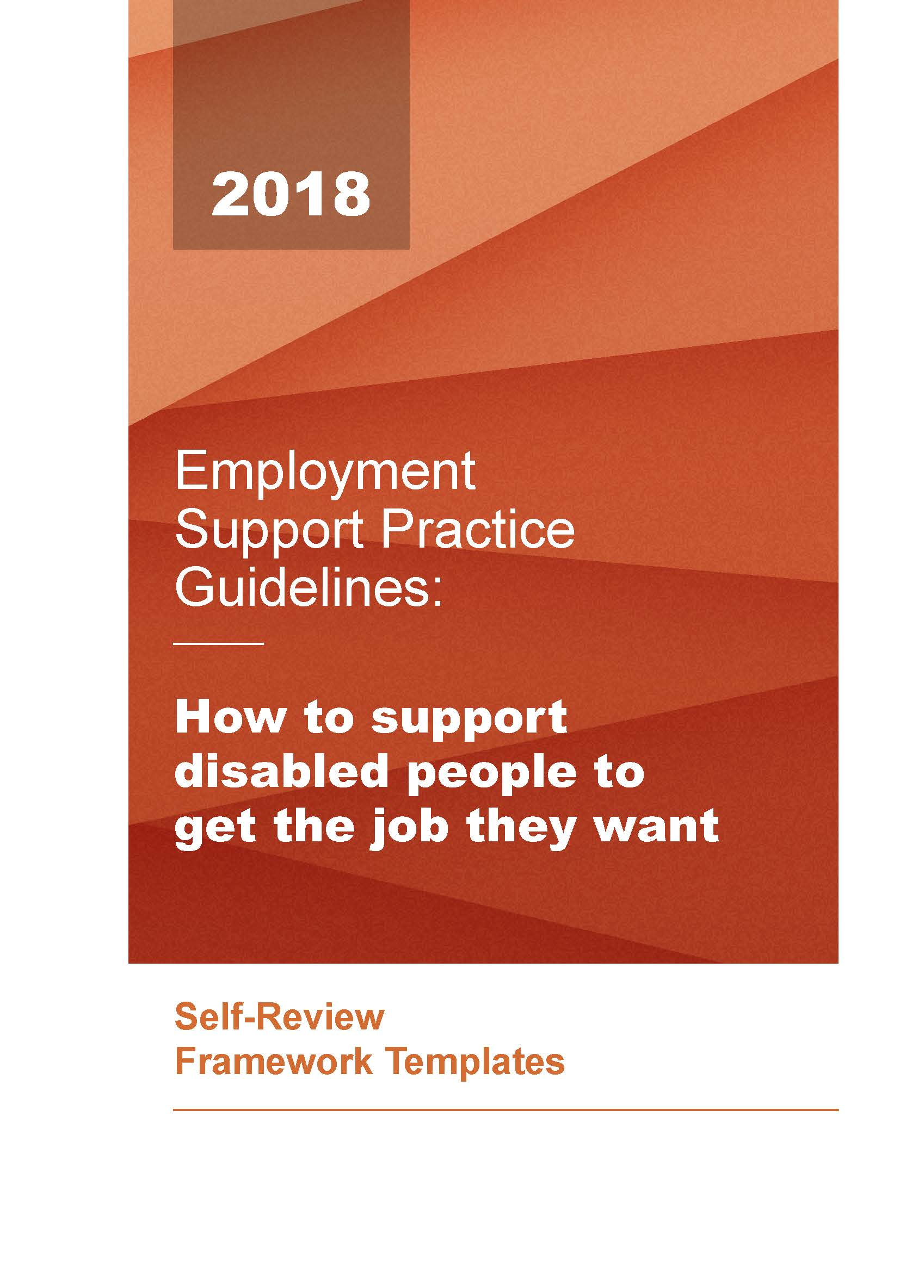

How to support

disabled people to

get the job they want

Self-review process
- Spend some time as an employment support team familiarising yourselves with the Employment Support Practice Guidelines and the Companion Document - Evidence and Resources.
- Meet regularly with relevant colleagues to self-evaluate your employment support service against one or two of the Practice Guidelines. Try to reach consensus on what each quality indicator means for your services.
- Make sure you involve disabled people and family members in your self-review process as part of the review team – their experience and perspective is critical in reviewing your agency’s performance, development and governance.
- Clearly identify evidence that supports the rating you have assigned to each quality indicator.
- Analyse the results and discuss the areas that seem to be strengths and those areas where there appears to be the need for development. Decide on the priorities for development and clearly identify action steps needed.
- Celebrate success and consider how such positive experiences can be made accessible to disabled people, families, whānau, employers and funders.
- Record the tasks, activities, and changes that need to be undertaken, with timescales and identify who will be responsible for each one.
- Review progress quarterly with your management team.
- Present annually to your managers/directors.
- Use your organisation’s Annual Report as an opportunity to celebrate success.
- Ensure your organisation’s business planning process has regard to your ambitions as an employment support provider.
- Collaborate with other providers to build the capacity and capability of the wider employment support sector.
- Consider ways to overcome the systemic issues which may be inhibiting the realisations of the Practice Guidelines.
- Commit to the development of this organisational self-review and consider how it can contribute to any external evaluation process.

Ratings Key
VERY GOOD | Very strong and consistent evidence to support  quality practice
GOOD | Some good examples of evidence to support  quality practice
FAIR | A few examples of evidence to support quality  practice, but patchy
POOR | Little or no evidence to support quality practice

Review Team

Review date(s)

Practice Guidelines 1
Any disabled person who wants to work has opportunities to received skilled support to get work

 | Quality Indicators | Very Good | Good | Fair | Poor | Comments/Evidence | Action
1.1 | Your website and promotional information regrading your service indicates your commitment to the values and principles of the Practice Guidelines
1.2 | You demonstrate a clear attitude that a disabled person’s declared desire to work and willingness to do what it takes to get employment shall be the only requirements to access employment services
1.3 | You are well known to disabled people’s networks in the areas in which you work – you have positive relationships with the disability community and you are able to tap into that wider expertise as required. You understand the labour market and are well connected to employer and business groups
1.4 | You are well connected with other employment support agencies (both locally and nationally)
1.5 | You actively work with local Māori, Iwi and Hapū to ensure disabled people who identify as Māori who want to work are engaged in a culturally appropriate way
1.6 | You actively work with local community groups to ensure disabled people who identify as being from other ethnic backgrounds who want to work are engaged in a culturally appropriate way
1.7 | Information you provide is accessible in a range of formats, the way in which you interact with a disabled person demonstrates an understanding of disability, and our buildings are welcoming and easily accessible
1.8 | You know about changes in the disability sector and how they will impact employment support and are open to new ways of working that follow on from this
Practice Guidelines 2
The disabled person’s goals and aspirations drives the update of employment support

 | Quality Indicators | Very Good | Good | Fair | Poor | Comments/Evidence | Action
2.1 | It is clear that the disabled person is listened to and enabled to explain their aspirations
2.2 | Any work assessment and planning process should be underpinned by the strengths and interests of the disabled person. The process includes opportunities to discover and explore a range of employment opportunities that match a person’s strengths and interests
2.3 | You will ensure the disabled person determines the type of work they want and identify imaginative and practical solutions to ensure any barriers to get that work are minimised/removed
2.4 | You will work with the disabled person to identify and obtain any skills, training or qualifications that will be necessary to get any particular job
2.5 | You will recognise that the degree of support a disabled person requires for daily living does not prevent them from seeking work. Indeed, such support could enhance, rather than reduce, their opportunities to get a job, including self-employment
2.6 | You will be able to demonstrate success stories where you have worked in partnership with a disabled person to successfully overcome barriers to work

Practice Guidelines 3
People and agencies involved in a disabled person’s life are encouraged to understand the importance of work as an achievable outcome

 | Quality Indicators | Very Good | Good | Fair | Poor | Comments/Evidence | Action
3.1 | The benefits of work are clearly set out and you are prepared to discussed these with disabled people, families and whānau
3.2 | You are encouraging and welcoming to families and whānau
3.3 | You are active in seeking to understand the importance of a person’s background and culture
3.4 | You don’t make assumptions but will be guided by the disabled person and the people/agencies they want to involve in the process
3.5 | You offer your employment support expertise to other professionals (including teachers and medical/health professionals) to promote and build an understanding of the value of work for disabled people
3.6 | You actively promote the benefits to businesses and the wider community of disabled people being more visible in the workplace
3.7 | You are committed to disabled employees receiving the same wages and conditions as their non-disabled colleagues

Practice Guidelines 4
Disabled people experience a personalised service. This means getting individually tailored, ongoing employment support to get and maintain a job

 | Quality Indicators | Very Good | Good | Fair | Poor | Comments/Evidence | Action
4.1 | Staff are encouraging and optimistic that they can find work opportunities based on a disabled person’s unique situation
4.2 | You will listen to individuals (and their close “supporters”), get to know individual job seekers well and show you understand individual’s situations
4.3 | You lead by example in employing a diverse workforce that reflects local demographics
4.4 | You will focus on getting people into work first and to train on the job because that is what is proven to work best
4.5 | Sufficient time will be available to work together on what is needed to prepare well for job applications and interviews including time afterwards to review what went well and what could have gone better
4.6 | You will assess what is needed in terms of supports or workplace accommodations and how these can be created/sourced in a timely manner
4.7 | People are always matched to jobs to the mutual benefit of the disabled job seeker and the employer
4.8 | You will identify what is needed to prepare the employee for the commencement of duties
4.9 | When the job has started, you have the skills and the time to be available for the employee, as required
4.10 | You work out with the employee what to do if things don’t go as planned
4.11 | You have purposeful, regular ongoing contact to assist the employee to build confidence and positive relationships in the workplace. As well as ensuring the job is working out for the employee, this process can also support the building of supports that naturally occur in workplaces and it can also provide opportunities to identify potential steps for further career development
4.12 | You remain available to the employee until it is clear that you are no longer needed and will be responsive to any chance in circumstances thereafter

Practice Guidelines 5
Employers know about and have confidence in employment support services, the benefits of employing disabled people and the importance of building natural supports in the workplace

 | Quality Indicators | Very Good | Good | Fair | Poor | Comments/Evidence | Action
5.1 | You can demonstrate that you are known o local employers and their representatives
5.2 | You show you understand the local labour market and its requirements
5.3 | You have positive relationships/partnerships with, and work with local secondary schools to ensure disabled students will have the best chance to access the local labour market, including supporting work experience
5.4 | You are successful as promoting the benefits and advantages of employing disabled people
5.5 | You keep employers in touch with what’s available to assist them to employ disabled people
5.6 | You support prospective employers to understand individual job seekers’ skills, talents and strengths as well as their learning/development needs, and disability support needs
5.7 | You have the skills to consider how a person’s strengths may fit an employer’s needs by being able to suggest adaptations to an existing role or to create a new role as necessary
5.8 | People are always matched to jobs to the mutual benefit of the disabled job seeker and the employer
5.9 | You identify what is needed to prepare the employer for the commencement of duties
5.10 | When the job has started, you have the skills and the time to be available for their employer, as required
5.11 | You work out with the employer what to do if things don’t go as planned
5.12 | You are pro-active in assisting the employer to consider how natural workplace supports can develop and enhance the experience of the employee over time
5.13 | You assist in building the employer’s capability to support the disabled employee but will remain available until it is clear you are no longer required and, if the circumstances change, be ready to step in again

Practice Guidelines 6
Providers of employment support have the knowledge to support each disabled person to get a job and develop a career of their choice

 | Quality Indicators | Very Good | Good | Fair | Poor | Comments/Evidence | Action
6.1 | You understand the income support systems (Work and Income, ACC), have a good relationship with Work and Income/ACC staff and can enable disabled people, families and whānau to understand the impact of work on their financial circumstances
6.2 | You have expertise in knowing what subsidies, training and other supports are available to disabled people and employers
6.3 | You understand tax law and can enable disabled people, families and whānau understand how this will impact their circumstances for any given job
6.4 | You understand employment law and particularly around what the rights and responsibilities of employees are in the workplace
6.5 | You are familiar with Health and Safety requirements in the workplace and can ensure these are not used as inappropriate barriers to employment
6.6 | You are familiar with Privacy Legislation thereby enabling disabled job seekers to maintain control over their personal information and ensuring employers understand their responsibilities in handling personal information
6.7 | You know about the rights of disabled people as defined by the United Nations Convent ion on the Rights of Persons with Disabilities and the New Zealand Human Rights Act
Practice Guidelines 7
Providers of employment support services direct and lead their organisation in ways that promote these employment support practices in partnership with disabled people

 | Quality Indicators | Very Good | Good | Fair | Poor | Comments/Evidence | Action
7.1 | You can demonstrate your commitment to do the things that are proven to be successful
7.2 | You are able to recruit and keep great staff who are skilled in employment support
7.3 | You actively recruit disabled people
7.4 | Employment specialists are actively encouraged to be innovative, developing new approaches/ways of working and contributing to an understanding as to what works effectively in NZ environments
7.5 | You can show how disabled people influence the way your agency is governed, directed and managed through having people with personal experience of disability on your boards and within your leadership teams
7.6 | You can demonstrate you work well with other agencies
7.7 | You are actively involved in employment support networks (locally and nationally), including mentoring new providers/practitioners

Practice Guidelines 8
Providers of employment support services, measure how good they are at getting people into work and strive to continually improve their employment services to disabled people, to employers and to funders

 | Quality Indicators | Very Good | Good | Fair | Poor | Comments/Evidence | Action
8.1 | You publish your track record for getting employment outcomes
8.2 | You regularly survey the people who use your services, and employers about the things that matter to them and make changes as a result of the feedback
8.3 | You participate in research to progress evidence-based practices and to test the effectiveness of new things that you try out
8.4 | You invest in the ongoing development of your staff
8.5 | You are committed to assessing/evaluating the wider impact of employment on the wellbeing of disabled people and their families and whānau

It will be noted that there is a common language within Practice Guidelines 4 and 5 with one set applying to the job seeker and one the employer. The work of the provider is to connect, broker and build rapport between these two, in the areas described, to mutual benefit

