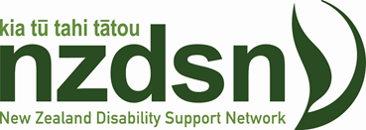

New Chief Executive Appointment for New Zealand Disability Support Network (NZDSN)
On behalf of the board of NZDSN I am pleased to be able to announce Peter Reynolds as the new Chief Executive of the New Zealand Disability Support Network effective 16 August.
The disability sector is about to go through a period of great change as we navigate system transformation and the wider reforms of the health and disability review. We look forward to Peter taking up the reigns at a crucial time for our members as they navigate these changes and to further NZDSN’s vision of an inclusive New Zealand where all disabled people are included and valued.
Peter’s strengths in the areas of leadership, relationship and stakeholder management, advocacy, understanding of the health and disability sector, communication/media and machinery of government will be of benefit to him in this new undertaking.
Peter leaves his current role as Chief Executive of the Early Childhood Council (ECC) that he has held for the last 12 years. In addition to the ECC role Peter has held leadership roles within the not-for-profit, and the wider health sector which has had crossover with the disability sector. He has also been a Community Broadcaster for various public and private radio stations.
Peter is married to Margaret, a retired registered nurse. Kristen, their adult daughter, lives at home and is studying web and graphic design. Peter enjoys yelling at rugby referees on the TV and supports the Hurricanes. To “relax”, Peter chases a little white ball around a large green field euphemistically calling it golf and enjoys movies, theatre and the Wellington restaurant scene.
I am sure you will all join me in welcoming Peter to the role when he commences on 16 August.
Sean Stowers
Chair, NZDSN

