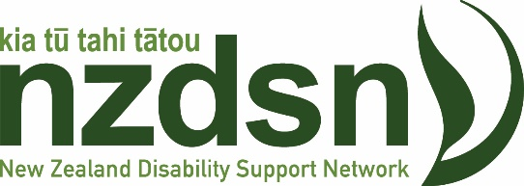

NZDSN Media Release Monday 11th October 2021

“A vaccine mandate for health and disability workers is an important move to protect disabled people from COVID-19”, says New Zealand Disability Support Network CEO Peter Reynolds.

NZDSN represents a network of not-for-profit organisations and some for-profit NGOs that provide support services to disabled people.

"Disabled people often have conditions that may make them less resilient to COVID-19 and are exposed to close contact with their carers and other workers in the health and disability sectors. COVID in the community presents a serious threat to disabled people and every step must be taken to protect them," says Mr Reynolds.

"We support the Government's announcement that anyone conducting high risk work in the health and disability sectors must be fully vaccinated by 1 December. This will provide an important layer of defence to the safety and well-being of disability support workers, the disabled people they serve, and their families.

"NZDSN polled its member disability support service providers earlier last week on the extent to which they supported the call for mandatory vaccination of support workers. Over 71% were in favour of taking this precautionary and protective step.

"We are keen to work with the Ministry on the implementation of this mandate, and to lift the vaccination rate of disabled people. It is clear that the deployment of vaccines in our communities has not been without issues. We want to work with Health officials to clarify which roles are covered by the mandate and ensure it is implemented as smoothly as possible," says Mr Reynolds

