News update 15/12/2021

Inside this issue

Inside this issue 1
A message from our CEO 1
What’s happening in our sector 1
Regional news 2
Auckland regional network 2
Member profile 2
Upcoming events 2
Members’ Only Facebook and LinkedIn Groups 2

A message from our CEO

What next and what happens if your support worker is stood down? Peter looks at this and the new Ministry for Disabled People as well as the hot topic of pay equity.

Facebook
LinkedIn

Peter Reynolds

What’s happening in our sector

Traffic Light System requirements for Employment Support

More about Employment Services Support.

LinkedIn
Facebook

New text service to support disabled peoples’ vaccinations
A new text service to support disabled peoples’ vaccinations has been set up by Whakarongorau Aotearoa on behalf of the Ministry of Health in response to feedback from the disability community. You can read all about it here.
My Vaccine Pass – group requests
The process to request a pass on behalf of a group of people in someone’s care has been added to the Covid 19 website: https://bit.ly/31FpSuB
Facebook
LinkedIn

Health and Safety Guidance
MoH and Worksafe are jointly developing guidance for providers of disability support services on complying with their responsibilities under the Health and Safety at Work Act 2015. There have been a number of recent prosecutions in this area and it is felt that guidance supported by training opportunities may help reduce this in future.
Pay equity
Word from the MoH is that the pay equity CPI adjustment will be paid early in the New Year. Further details still to come.
Sustainability payment for residential services

Further information on the work being done in the Equitable Residential Pricing Project and the Sustainability payment.

Facebook
LinkedIn

Graduate Diploma in Disability Sector Leadership
We had a fantastic response to our call for applications for a fees-free position that the Open Polytechnic have made available to NZDSN members to enrol for the Graduate Diploma programme. We are working through these applications now. People will be notified before Christmas if they have been selected.
MSD Training Fund - reminder
The Training and Workforce Development Fund supports Employment, Participation and Inclusion Service providers to improve and develop their services through learning and training.
People can apply any time throughout the year. Go to our website for further information.

Regional news

Auckland regional network
This is our Auckland Executive facilitator, Mireille Vreeburg’s swan song as she will be leaving us on the 15th December, so we have her reflections on the last 7.5 years, information on planned meetings for 2022 as well as updates from meetings in November.

Facebook
LinkedIn

Member profile

This month our member profile is Thumbs Up Trust, which was established to support the needs, aspirations and on-going development of young people with intellectual and physical disabilities to enable them to:
- Actively participate in the life of their community and gain enjoyment from its facilities
- Learn and develop new skills
- Engage in a range of cultural, artistic, recreational and leisure activities
- Develop friendships and a sense of belonging to a community
- Contribute in a meaningful and positive way to their community
- Feel valued and enjoy a sense of achievement from meeting challenges
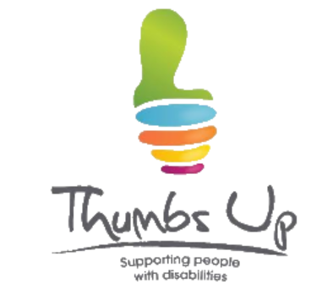

Upcoming events

Our Safeguarding a safe Life Workshop was sold out and our 2022 events have not yet been scheduled, but don’t worry, we’ll let you know in plenty of time!

Members’ Only Facebook and LinkedIn Groups

Our open Facebook page is:
NZDSN Facebook
Our Members’ Only Facebook group is:
Facebook Members' Corner
Our LinkedIn New Zealand Disability Support Network profile is:
New Zealand Disability Support Network LinkedIn
Our Members Only LinkedIn profile is LinkedIn Members Only

From our family to yours, we wish you a happy holiday and safe travels. We look forward to seeing you in 2022!
The NZDSN team

