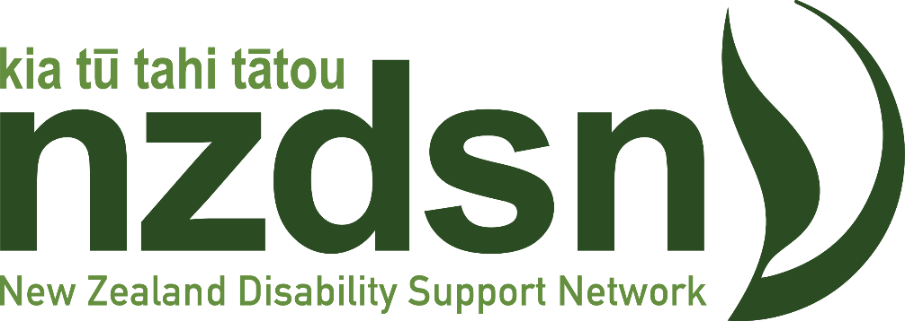

Submission on the

Proposed expansion of Vaccinator working under supervision roles to support the health and disability workforce

Name of organisation: The New Zealand Disability Support Network

Contact person: Doctor Solmaz Nazari Orakani, Policy Analyst
Peter Reynolds, Chief Executive

Postal address: Level 8, Prime Property Tower
86-90 Lambton Quay
Wellington Central, 6011

Email address: policies@nzdsn.org.nz
peter@nzdsn.org.nz

Phone: (04) 473 4678
Thank you for the opportunity to make a submission on the proposed expansion of Vaccinator working under supervision roles to support the health and disability workforce. The New Zealand Disability Support Network supports the objectives of the proposal to amend the Medicines Regulations 1984 and develop associated policies to enable a ‘Vaccinating Health Worker’ to administer a range of vaccines to people aged 5 and up, under the clinical supervision and direction of a qualified health practitioner.
We have some general and specific comments on how the proposal can be improved to work better for disabled people and the disability sector.
About NZDSN
NZDSN is a national network of over 160 organisations that provide support services to disabled people, mainly through contracts with government. We are governed by an elected Board from the wider membership and employ a full time Chief Executive with a small staff team mostly based in Wellington.
Our focus is leading and influencing change that supports inclusive lives for disabled people. We provide a strong voice and policy advice to government on behalf of our members and facilitate innovation and quality with providers.
General comments
NZDSN and other disability sector groups support expanded workforce capacity. We agree the current immunisation workforce needs to be upskilled, supported, prepared, and more resilient to meet potential high demand for immunisations. We welcome, therefore, the proposal to train and upskill existing workforce and create a new “Vaccinating Health Worker”.
While we agree the establishment of the new workforce will have sizable benefits for communities across New Zealand, we think the proposal fails to make an integral component of their respective training and competencies to understand and acquire skills required for working with disabled people. This is a critical issue that we want to see recognised by the proposal for the following reasons, amongst others:
- Disabled people are the largest minority group in Aotearoa with one in every four New Zealander having at least one impairment/disability

- Disabled New Zealanders interact with the health system at rates twice as high as the nondisabled

- The disability community is not a homogeneous group; it is extremely diverse with many disabled people having significant health needs

- There are complexities and nuances in communication with disabled people and obtaining informed consent
Therefore, we believe the “working with disabled people” core learning mentioned in level 1 training of the proposal is not sufficient to equip the new workforce with all the skills required to work with disabled people.
Specific comments
- We support the proposal for introducing a capability matrix, and we want more disability-related training for the new workforce and their supervisors.

- The capability matrix should recognise “disability culture” as a component of cultural competency training for the new workforce. We also want the supervisors be provided with this training.

- We suggest a consultation with the disability sector to determine and develop materials for the disability-related training for the new workforce and their supervisors.

- We want to see a greater level of accountability/awareness for the new workforce and their supervisors in their interactions with disabled people.

- Alongside creating the new workforce, we believe there is opportunity to upskill the clinical supervisors with additional disability-related training.

- We suggest disability-related training is structured into different levels of NZQA-recognised micro credentials, so, it can be made available for other health professionals.

- Considering that many disabled people might have underlying health conditions, we are concerned about the consumer safety in terms of the new workforce lack of medical/nursing/health knowledge and background.

As the peak body of disability support service providers, NZDSN supports the proposal to establish a new “vaccinating health worker” workforce. We welcome the opportunity to assist you in making sure the new workforce is sufficiently equipped with knowledge and skills required to appropriately interact with disabled people.

Statistics New Zealand, 2021.
Health And Disability System Review, 2021.

