News update 17/05/2022

# Inside this issue

Inside this issue 1

Member profile 2

Upcoming events 2

Register here 3

Members’ Only Facebook and LinkedIn Groups 3

**A message from our CEO**



*Peter Reynolds (CEO)*

Another month has swept by. As the borders are re-opening and COVID restrictions are lessening, we start to get back to some semblance of normal. Peter looks at Commissioner Paula Tesoriero’s report on the impact of Omicron on the support for disabled people and gives a Pay Equity update.

We also have an NZDSN Board meeting later this week and look forward to sharing an update with you on that as well as further pay equity issues.

Finally, its Budget week. Because of the focus on pay equity, there has been no word on any Budget-related general increase in provider rates. There are some rumours – not very nice ones in terms of any likely increase. NZDSN will keep you informed about what’s in the Budget after 2pm on Thursday. Keep an eye on your e-mails!

[Facebook](https://www.facebook.com/groups/memberscorner/posts/665301867902497/)

[LinkedIn](https://www.linkedin.com/feed/update/urn:li:activity:6930735604364173312?utm_source=linkedin_share&utm_medium=member_desktop_web)

**NZDSN Policy Analyst**

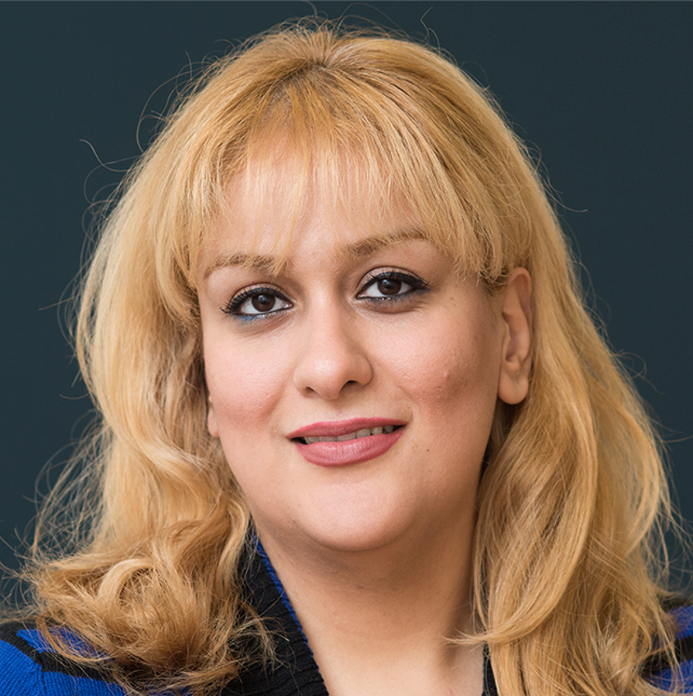

*Dr Solmaz Nazari (Policy Analyst)*

This month Solmaz has been busy responding to some of the Government’s policies and providing feedback to Ministry of Health on issues/topics.

[Facebook](https://www.facebook.com/groups/memberscorner/posts/665304397902244)

[LinkedIn](https://www.linkedin.com/feed/update/urn:li:activity:6930736932838653952?utm_source=linkedin_share&utm_medium=member_desktop_web)

**NZDSN Auckland Regional Co-ordinator**



*Kristi Shaw (Auckland Regional Co-ordinator)*

This month Kristi discusses meeting our members in Auckland and the items up for discussion agenda at the Auckland Regional Meeting on the 29th of June

[Facebook](https://www.facebook.com/groups/memberscorner/posts/665306644568686/)

[LinkedIn](https://www.linkedin.com/feed/update/urn:li:activity:6930738809621934081?utm_source=linkedin_share&utm_medium=member_desktop_web)

**MSD Training Fund reminder**

The Training and Workforce Development Fund supports Employment, Participation and Inclusion Service providers to improve and develop their services through learning and training.

People can apply any time throughout the year. Go to our [website](https://nzdsn.org.nz/training/) for further information.

**NZDSN National Employment Services**

**Co-ordinator**



*Gordon Boxall (National Employment Services Co-ordinator)*

This month Gordon met the new National Contract Manager for MSD, He also discusses the Diploma in Employment Support and Employment Support Guidelines.

[Facebook](https://www.facebook.com/groups/memberscorner/posts/665308861235131)

[LinkedIn](https://www.linkedin.com/feed/update/urn:li:activity:6930740090407178240?utm_source=linkedin_share&utm_medium=member_desktop_web)

# **Member profile**

This month our member profile focuses on Vaka Tautua



Vaka Tautua is a charitable organisation that aims to help improve the health and wellbeing of Pacific people in New Zealand.

We provide community support for older peoples, people living with disability and those needing support for mental health.

Vaka Tautua is a national ‘by Pacific, for Pacific’ health support service provider.

We run community programs and services that provide support especially to our older peoples, those living with disability or those seeking support for mental health.

We also offer shared management services to a number of smaller groups and trusts and have a history of strong Pacific community and health sector engagement.

Since 2009, we have been fully accredited with Telarc SAI QHNZ against the EQUIP4 Standards.

We want to support Pacific older people, people living with disability and/or mental illness to pursue their lifestyle choices.

Our programmes aim to encourage families and communities as a whole to respect, promote and safeguard the rights of our service users within the health and disability sector.

We are always striving to find innovative and creative ways to lead the on-going development of health and disability support services for Pacific Tautuapeople.

We aim to promote non-discriminatory practices and to bring positive change to the lives of our service users.

**Upcoming events**

**The next Auckland regional networking meeting for 2022.**

Wednesday 29th June 2022

9.30 am-12.30 pm

# [Register here](https://nzdsn.arlo.co/w/upcoming/)

# **Members’ Only Facebook and LinkedIn Groups**

Our open Facebook page is:

[**NZDSN Facebook**](https://www.facebook.com/NZDSN)

Our Members’ Only Facebook group is:

[**Facebook Members' Only**](https://www.facebook.com/groups/memberscorner)

Our LinkedIn New Zealand Disability Support Network profile is:

[**New Zealand Disability Support Network LinkedIn**](https://www.linkedin.com/company/new-zealand-disability-support-network)

Our Members’ Only LinkedIn profile is [**LinkedIn Members' Only**](https://www.linkedin.com/groups/14017065/)