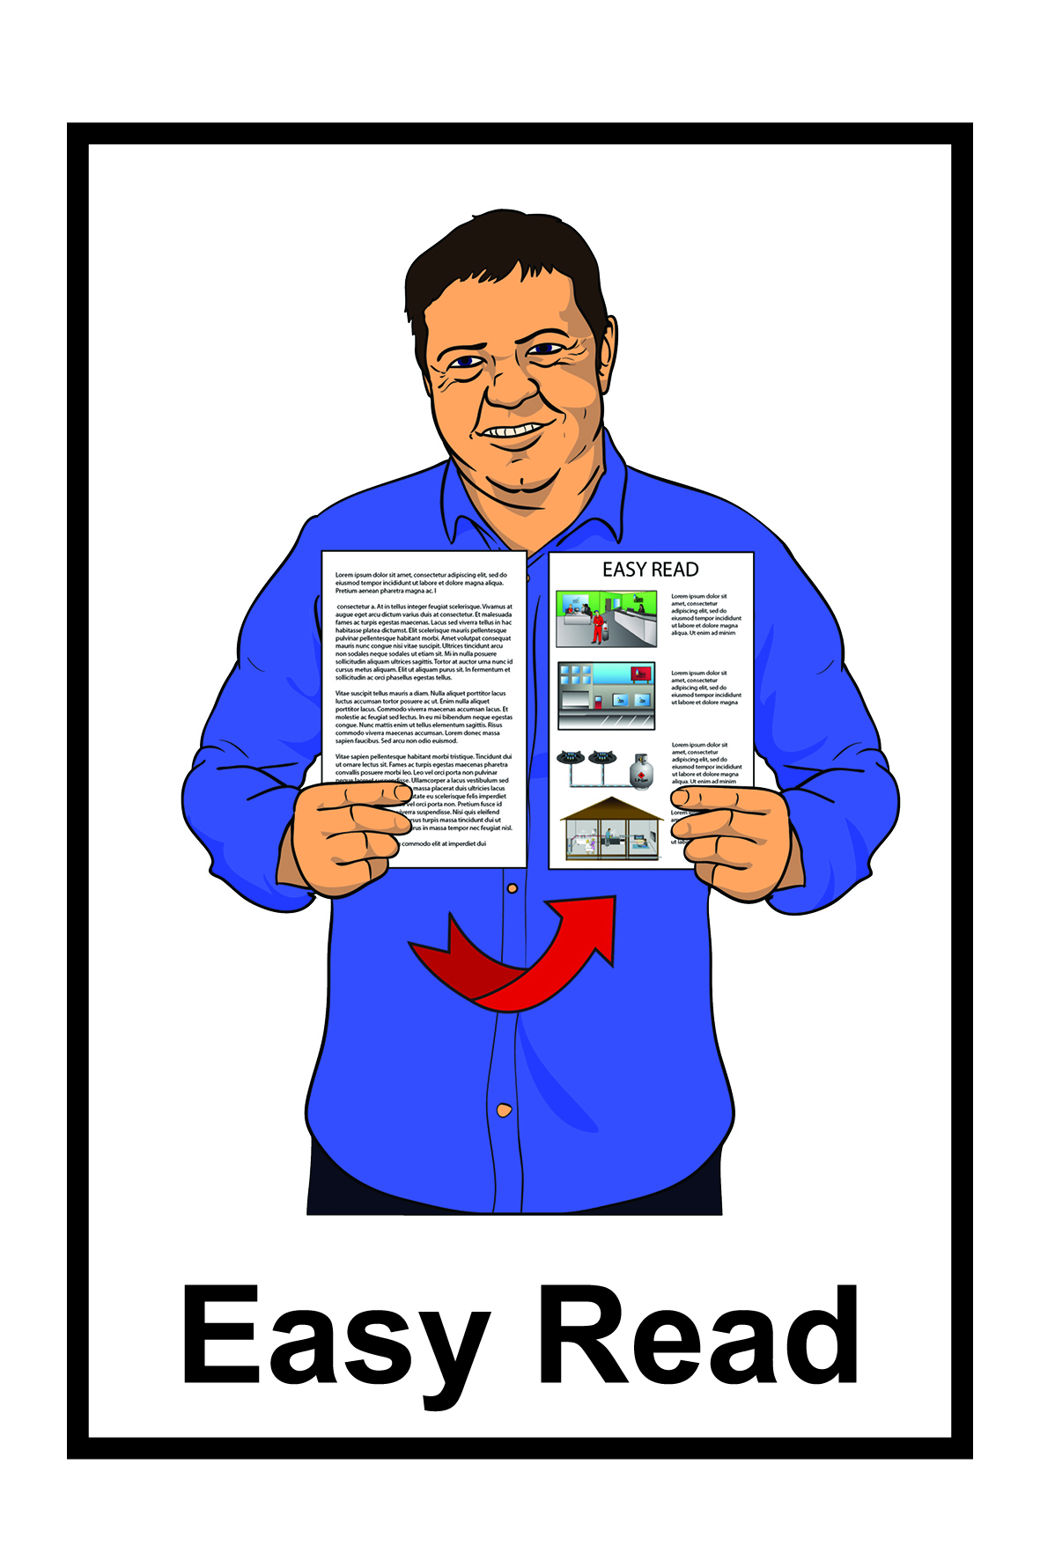
Would you like to be in some videos about the principles of Enabling Good Lives?

Do you get Enabling Good Lives support?
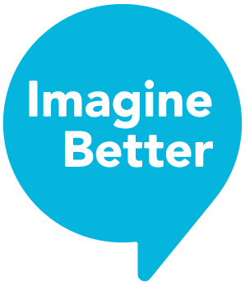

Imagine Better is looking for people who would like to share their Enabling Good Lives story.

Imagine Better is making some videos about the principles of Enabling Good Lives.

The videos will:

- show the principles of Enabling Good lives in action

- be used as a way that people can learn about Enabling Good Lives.
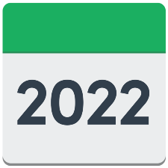
Let us know by 19 August 2022 if you are interested in sharing your Enabling Good Lives story.

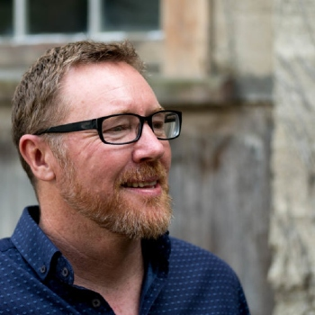
To let us know that you are interested or to find out more information talk to Tony Mclean at Imagine Better:

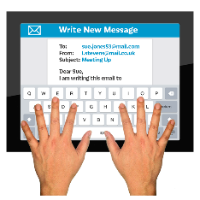
Email: Tony.Mclean@imaginebetter.co.nz

Phone: 0274 934 601

You can also find more information on the Imagine Better website:

www.imaginebetter.co.nz/enabling_good_lives_video_resources_project

People First New Zealand Inc. Ngā Tāngata Tuatahi translated this information into Easy Read using images from Photosymbols.

