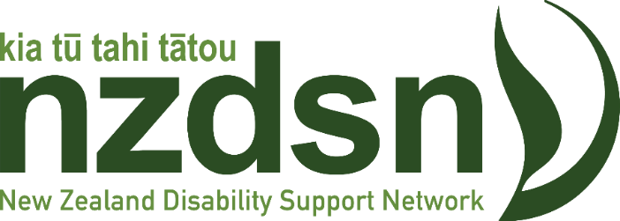

Strategic Plan

2022 – 2027

From our Constitution, our Purpose is…
to promote, encourage, support and represent members in regards to the provision of high quality equitable disability services and support for disabled people and families throughout New Zealand to enable good lives.

Our Vision for the future is…
an inclusive New Zealand where all disabled people are valued, their human rights are promoted and protected, and they are enabled to maximise their potential as citizens.

Our Values are:
- We are committed to work in a manner that upholds the Treaty of Waitangi and its principles
- We are committed to the UNCRPD and its principles
- We are committed to the principle of mana Motuhake (self-determination) of disabled people
- Being a strong advocate for our members and the sector
- Where needed and appropriate, we will agitate to ensure the voice of our members is heard and seek to make a strong impact to ensure our member’s issues are addressed
- We are transparent in all that we do
- We are responsive to the needs of our members and timely in offering advice and support
- We desire a strong partnership with our members, with others in the disability sector and with those who design and implement policy and service purchasing and funding frameworks
- We are committed to unifying our sector so that every disabled person feels they are consistently enabled to enjoy a good life.

To achieve our Vision, we will:
  - Member Development, Support and Satisfaction
- Encourage and support membership by disabled people and whānau who are employing staff
- Act on the need to market among non-member providers
- Increase the value to our members of their membership with NZDSN by building our knowledge of our membership and the various segments/ types of member, the issues they face and the support needs they have
- Build and deliver a support framework available to our members to better meet their needs (eg: tools and templates that interpret the impact of policy to practice so members can design relevant service responses to the transforming system)
This will be measured by member satisfaction through conducting research and environmental scans to ensure that NZDSN’s support is responsive to their common needs and priorities and that members rate NZDSN’s activities as value for money.
  - Workforce Development
- Call for and participate in the development and implementation of a Disability Workforce Strategy that:
  - Services delivered for disabled people should be determined by them
  - Promotes disability leadership throughout providers
  - encourages our members to set aggressive targets for increasing their number of disabled employees
  - Identifies the nature of the workforce required to meet the wider implementation of Enabling Good Lives and the needs of disabled people over the next ten years and beyond
  - Considers the range of roles and impact of technologies over that period
  - Attracts people into the workforce and retains them
  - Creates a career pathway for those seeking it, including ongoing professional development opportunities and qualifications frameworks
  - Addresses the current critical workforce shortage
  - Recognises the investment in workforce by providers and reflects this in service funding arrangements.
- Reserve the right to comment on the proposed Disability Workforce Strategy so that it recognises the actual skills staff need to acquire
This will be measured by the publication of a Disability Workforce Strategy that embodies the voice of providers and that includes a strengthened workforce in capability and capacity promoting sustainability and changing needs.
  - The Operating Environment (reflecting legislative, regulatory and policy issues)
- Advocate for our members to set aggressive targets for increasing their number of disabled employees and engage with relevant Ministries on establishing how this will be measured, reported and supported.
- Build on our efforts to reflect our members’ views on issues that relate to the operation of high-quality disability support services at all levels, including (but not exclusively) on matters relating to funding; service design, engagement and monitoring; workforce development; and the uncertainty created by the COVID pandemic.
This will be measured by NZDSN being a sought-after influencer on behalf of its membership leading to positive, long term changes that improve access and quality of disability support services. Furthermore, this will be promoted by NZDSN's strong voice to the government on matters of policy, service design, and legislation.
  - Financial Sustainability
- Explore and secure alternative revenue sources to continue to offer value to our members and to sustain NZDSN’s future viability.
- Explore opportunities for partnerships where members can collaborate (and share efficiencies e.g. around shared services) rather than compete.
- Explore and secure opportunities to use the collective purchasing power of the membership to good effect. E.g. insurance, director liability, vehicles, travel/hotel costs, employee discounts etc.
This will be measured by financial measurable growth that is sustainable through diverse revenue streams to fund the innovation required to keep NZDSN relevant and useful to its members.
NZDSN will also regularly take the opportunity to review the wider operating environment to consider the challenges and changes facing the provider sector and disabled people generally. This strategic plan will be reviewed annually

