News update 11/11/2022

# **Inside this issue**

Inside this issue 1

A message from our CEO 1

News from the NZDSN Board 1

NZDSN Policy Analyst 2

NZDSN Auckland Regional Co-ordinator 3

MSD Training Fund 4

Member profile 4

Welcome To Our New Members 4

Upcoming events 4

Register for Upcoming Events 4

Before You Go 4

Members’ Only Facebook and LinkedIn Groups 4

# **A message from our CEO**

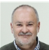

*Peter Reynolds (CEO)*

It’s been a busy quarter for submissions, with work completed on our submission on the Accessibility Bill and for the proposed regulations associated with the new Incorporated Societies Act and the changes to the NZ Sign Language Act.  We have also completed work on a Housing Policy document that provides the backdrop for NZDSN’s activities in this area.  We continue to push for an increase in accessible social housing with Kainga Ora and Ministers.

Work on the Care and Support Workers’ pay equity claim is full steam ahead, with the appointment of a project manager to oversee the work that needs to be done by both employers and unions.  The next activity on the agenda is getting interviews of staff underway for those employers named in the claim.

Work is also now underway to plan our NZDSN Conference for next year.  Keep an eye open for more on this over the next few weeks.

I have also had some success with Whaikaha officials to start work now on a contingency plan in the event of another serious outbreak of COVID, or any other virus with a major impact.  We know COVID and Influenza are cold weather viruses and that if an outbreak is going to occur, it will be next winter.  So what’s the plan?  And what have we learnt from our experience to date that can streamline the response for you and reassure disabled people about the continuity of their support.

The final item I wanted to brief you on concerns workforce.  At a national level there have been several groups concerned with workforce strategy and workforce planning.  And several ministries involved in this space to, like Whaikaha, Ministry of Health, Ministry of Business, Immigration and Employment, etc.  There needs to be some co-ordination of effort so that these strategies don’t cross over one another or conflict.  In addition to that strategic view, I have again emphasised the immediate need for action in response to the current support worker shortage.  I continue to worry that this will get worse before it gets better – with significant pay rises for care assistants and other comparable roles to support workers driving a further exodus from our sector.

I can see the high levels of activity continuing up until Christmas Eve and beyond.  That’s OK so long as it delivers a positive result for you and the disabled people you serve.

# **News from the NZDSN Board**

The NZDSN Board met for the first time since the AGM on the 20th October.  I can report that Sean Stowers was re-elected Chairperson, and Karen Scott re-elected as Deputy Chairperson.  We welcomed three new Board members: Colene Herbert (CCS Disability Action), Samantha Lee (A Supported Life Hauraki Trust), and Tony Marsden (SILC).  Richard Williams (NZ Health Group) has also been co-opted onto the Board.  In addition, here's a snapshot of what was covered in the meeting:

There was plenty of discussion on the Environmental Scan tabled, with particular focus on the work being done with Statistics NZ, ongoing issues with Immigration NZ, the UNCRPD Report and what this means for (particularly residential) providers, housing issues (particularly social housing issues with Kainga Ora), pay equity, workforce concerns and funding concerns.

In terms of pay equity, the government has appointed a project manager to co-ordinate with both the employer group and union group.  Although this took some time to sort out, good progress is now being made to advance the Care and Support Worker Claim.

A verbal report was received from the EGL National Leadership Group spokesperson.  And two new members have been appointed to the Tui Tuia Committee, being Colene Herbert and Taki Peeke (IDEA Services).

# **NZDSN Policy Analyst**

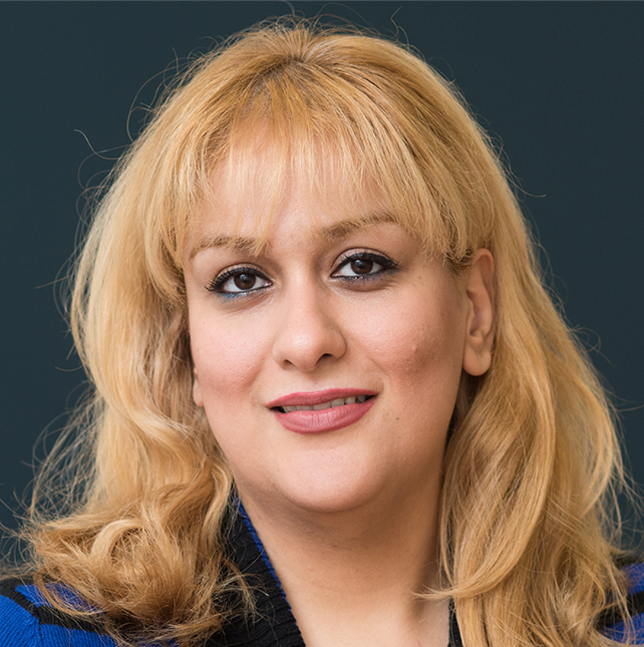

*Dr Solmaz Nazari (Policy Analyst)*

The Board report for September can be seen in the [NZDSN Environmental Scan for September](https://nzdsn.org.nz/environmental-scan-september-2022/) This report covers amongst other topics, politics, the economy, COVID-19, immigration and the Disability Survey 2023.

**Accessibility for New Zealanders Bill:** We made a submission on the Accessibility for New Zealanders Bill. We supported the objective of the Bill to remove barriers and improve accessibility for disabled New Zealanders. However, we believe the Bill in its current form does not go far enough. Without major revisions the Bill falls short of recognising the rights of disabled people and ensuring that New Zealand Government meets its commitment to and obligations under UNCRPD. You can read this submission [here](https://nzdsn.org.nz/wp-content/uploads/2022/11/NZDSN-Submission-on-the-Accessibility-Bill.pdf)

**NZSL Act** **Consultation 2022:** We also made a submission on NZSL Act. We supported the objective of the amendments to better align the Act with UNCRPD, strengthen Deaf community leadership in promotion of NZSL, addition of a monitoring mechanism to the Act, and incorporating Government’s obligations under Te Tiriti o Waitangi in the Act. We believe the amendments could improve the realisation of the rights of people with disability in New Zealand and contribute to the fulfilment of the New Zealand Government's commitment to the UNCRPD. You can read this submission [here](https://nzdsn.org.nz/wp-content/uploads/2022/11/NZDSN-Submission-on-the-NZSL-Act.pdf)

**Consultation on regulations for the Incorporated Societies Act 2022:** following the major overhaul of incorporated societies legislation, MBIE had a consultation for various regulations of the new Incorporated Societies Act 2022. The consultation was a discussion document with specific questions about various sections of the Act. You can find NZDSN’s submission [here](https://nzdsn.org.nz/wp-content/uploads/2022/11/20221102-Proposed-Incorporated-Society-Regulations.pdf) .

**Housing policy paper:** We continued working on our housing policy paper, and the final draft is ready. In this paper, we provide a comprehensive overview of (accessible) housing in New Zealand, issues, contributing factors, international best practice, and a range of recommendations. Our next step in this area is to run a campaign, lobby for more accessible housing, and work with Kāinga Ora and other stakeholders.

**Surveying City Council’s around New Zealand about disability issues:** We contacted newly elected mayors across New Zealand, and sent them a survey on disability issues, and how local governments are planning to address disability related issues. We will report the results in due course.

# **NZDSN Auckland Regional Co-ordinator**

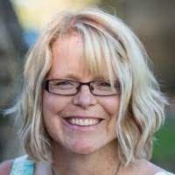

*Kristi Shaw (Auckland Regional Co-ordinator)*

Kristi covers the Accessibility Summit held on the 5th October in Auckland.

What a fantastic start we had to the first stage of the Accessibility Summit on the 5th October, with all of us finishing the day **Energised, Connected and Hopeful.**

Together, through sharing a guided kōrero, we discovered when accessibility was at its BEST, which identified what gave energy to us collectively. This helped identify our collective strength, our positive core as a sector. Out of many, here were our top three:

1. **Accessibility of information and communication, awareness of who to ask, normalizing disability by talking about it**
2. **Meaningful connections**
3. **Whole of Life approach**

With these top themes used in our topic areas, we generated inspired creative visual and word images for the preferred **accessible** future we want to see. This is the foundation that will help us with the action part – the designing part – with focused teams that include a variety of stakeholders, all wanting that preferred accessible future that is inspired, created and supported in collaboration and partnership.

**We have a choice:**

**We can wait for change to happen TO us,**

**Or**

**We can co-create the change we want to see,**

**We can be part of creating a legacy.**

**That’s the second part - the Accessibility Summit will be on the 23rd Nov.**

This stage will be about co-creating focused ACTION for our topic areas: Health and Wellbeing; Employment, Training, and Education; Information, Technology, and Supportive Equipment; Programmes and Services; and Housing.

If these are areas you or your organisation are focused on, and you want to be active and part of the connection and collaboration with others, and you weren’t at the first Summit, **please email one of our Core Planning Group by Fri 18th Nov to indicate you want to join that focus team, and** [**Register**](https://nzdsn.arlo.co/w/upcoming/) **early for the Summit, there are limited spaces**:

|  |  |
| --- | --- |
| Linda Harun  Email Linda  [Linda.Harun@explore.org.nz](mailto:Linda.Harun@explore.org.nz) | Health & Wellbeing |
| Michelle Smith  Email Michelle  [MichelleS@lifewise.org.nz](mailto:MichelleS@lifewise.org.nz) | Programmes & Services |
| Michelle Creighton  Email Michelle  [Michelle@RescareHomesTrust.org.nz](mailto:Michelle@RescareHomesTrust.org.nz) | Housing |
| DeniseNicholson  [denise.nicholson@greenwaystrust.org.nz](mailto:denise.nicholson@greenwaystrust.org.nz) | Housing |
| Ngaire Jones  [NJones@accessable.co.nz](mailto:NJones@accessable.co.nz) | Information, Technology, Supportive Equipment |
| Tabatha Murray [Tabatha.murray@spectrumcare.org.nz](mailto:Tabatha.murray@spectrumcare.org.nz) | Employment, Education, Training |
| Claire Lewinski  Email Claire  [Claire.Lewinski@northable.org.nz](mailto:Claire.Lewinski@northable.org.nz) | Programmes & Services |

**Who will be there?**

The Summit includes a variety of stakeholders, working in a variety of topic areas: reps from Whaikaha, MSD, Auckland Council, Waitemata DHB, Auckland Disability Advisory Panel, Disability Providers, Disabled People/Whanau, and Small Businesses.

**Here is a taste of the energy you can expect at the next Summit:**

**“What we appreciated MOST about today”:**

**“What do we want MORE of?**

***What we have to look forward to in the 2nd Summit!***

We are looking forward to seeing you there! Need more information?

Email Kristi at [aucklandproviders@nzdsn.org.nz](mailto:aucklandproviders@nzdsn.org.nz)

**MSD Training Fund**

This fund supports Employment, Participation and Inclusion Service providers to improve develop their services through learning and training.

People are welcome to apply at any time throughout the year. Please go to our [**website**](https://nzdsn.org.nz/training/) for further information and to submit applications

.

**Member profile**



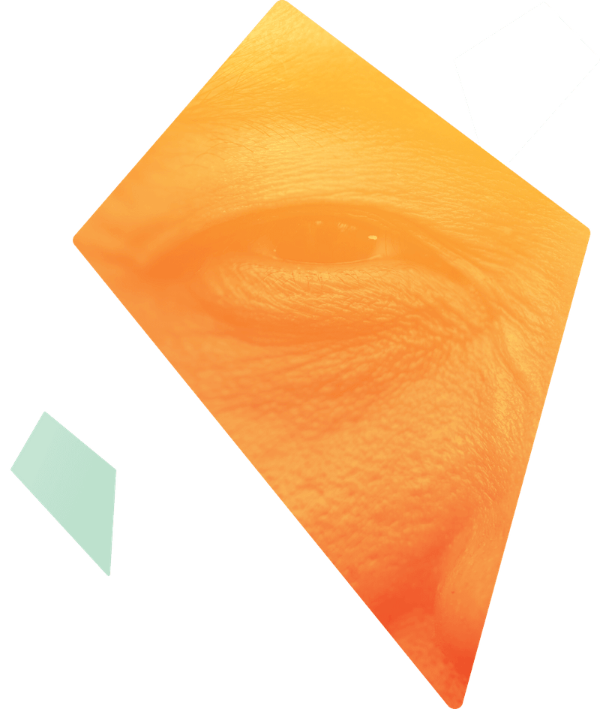

Flying Kites exists to lead the change we want to see in the disability sector. We believe everyone who needs it should be able to access disability support services that are as unique as the person they are designed for. People don’t fit in boxes, so neither should our support services. We are here to reimagine what disability support could look like for you, your friends and your whānau. Our key focus is on helping people with personal budgets (like Individualised Funding) to get the most out of their support through planning, progress towards independence and tailored recruitment. Services are provided on a fee for service basis

[Facebook Introduction](https://fb.watch/gz89N0hIpy/)

**To Contact Flying Kites:**

**Name** Ainsley Darvell  
**Phone** 022 528 5543  
**Ema**i [Hello@flyingkites.org.nz](mailto:Hello@flyingkites.org.nz)  
**Website**: [www.flyingkites.org.nz](http://www.flyingkites.org.nz/)

# **Welcome To Our New Members**

**Disabled Persons Centre Trust T/A Aspire Canterbury**

And

**ABI Rehabilitation New Zealand Limited**

# **Upcoming events**

**Auckland Regional Network Meeting**

Wednesday 23rd November

9:30 am – 12:30 pm

# [Register for Upcoming Events](https://nzdsn.arlo.co/w/upcoming/)

**Before You Go**

This month Gordon shares a 14 minute story of hope and inclusion.

[How to build inclusion into the everyday | Annamarie Jamieson | TEDxAuckland](https://www.youtube.com/watch?v=ltHMyyfCDqg)

**Members’ Only Facebook and LinkedIn Groups**

Our open Facebook page is:

[**NZDSN Facebook**](https://www.facebook.com/NZDSN)

Our Members’ Only Facebook group is:

[**Facebook Members' Only**](https://www.facebook.com/groups/memberscorner)

Our LinkedIn New Zealand Disability Support Network profile is:

[**New Zealand Disability Support Network LinkedIn**](https://www.linkedin.com/company/new-zealand-disability-support-network)

Our Members’ Only LinkedIn profile is [**LinkedIn Members' Only**](https://www.linkedin.com/groups/14017065/)