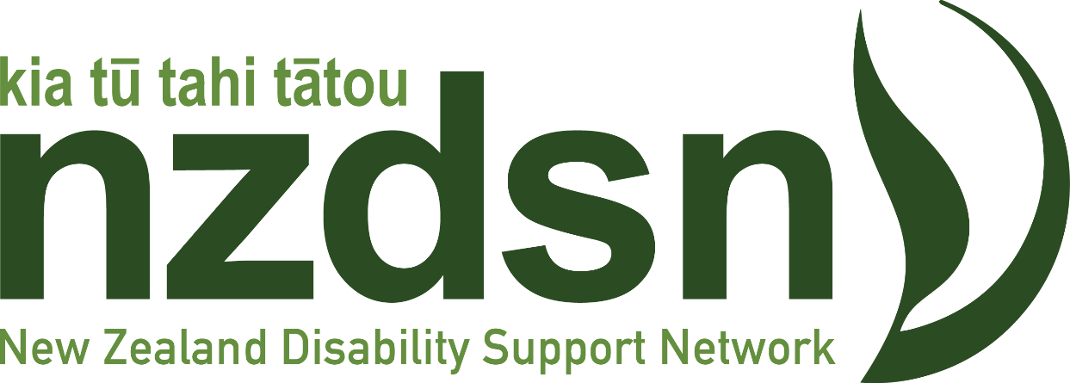
May Newsletter

And so, the Magical Mystery Tour continues! It is a remarkable thing when a Ministry alerts their Minister to the fact, they are within 48 hours of running out of money. In the midst of a bunch of austerity measures impacting on all Ministries along with job losses – and not just in the public service. Then to compound things, we have the PR case study of the year on March 18th with the launch of Purchasing Guidelines for equipment provision and those on Individualised Funding packages. While the apologies were pouring out of the Minister’s Office and Whaikaha, “refinements” to the guidelines themselves were proceeding much more quietly.

Surprising one’s Finance Minister and the PM is never a great career-enhancing move. Out goes Simmonds and in comes Louise Upston. The sector gets one wish in the form of an experienced Minister inside the Cabinet room. The Minister, perhaps not surprisingly, announces a review to better understand the financial pressures within the sector – what’s driving things and what can be done about it. Her popular quotes: “the Ministry must live within its means”, and “choice and control within fiscal boundaries”.

Whaikaha has established its CEOs’ Forum – a group of provider CEOs from across our sector, whose job it is to advise Whaikaha how to live within its means, particularly in the key areas of cost overrun. The three-person panel has been given six weeks to report back to the Minister. None of the panellists have direct experience of disability or indeed any prior awareness of the challenges the sector has been facing now for over a decade. Six weeks to get your head around things like disability support funding and how services are commissioned and contracted is a massive ask and one yet to be shown to be do-able.

What we do know is that none of the issues we face are new. And most-if-not-all have been previously examined through reviews, working groups and so on. Solutions abound if you know where to go look for them. Here’s hoping the three panellists have the time to read and talk to those in the know.

The Government’s Budget was released on Thursday 30th May amid the usual hype and hyperbole. Disability support received a $1.1 billion boost, which is very welcome. We now await the detail to see if any of that funding will make its way to provider cost of living increases.

Go here for NZDSN’s Budget summary

Relational Safety at the Auckland Regional Network Meeting on the 3^{rd of} July

Keeping our teams and tāngata Whaikaha/whanau safe is at the very heart of the work we do in our organisations and communities as Disability Support Providers.

We have a valuable opportunity to address safety from three different directions at our Auckland network meeting:
- Safe Reporting Practice and Framework
- Awareness & Strategies to Mitigate Online Grooming of Vulnerable People into Violent Extremism
- Building Resilience and Agency for Healthy Relationships for Intellectually Disabled
- Kua karangatia koe, You are invited!

Register Here by Thursday 27th June.

Philanthropy New Zealand has released a new guide that aims to help members to front foot support for communities to prepare for, respond to, and recover from disasters.
While members already play a big role in helping communities significantly in the aftermath of an event and to rebuild after a disaster strikes, the new Prevention, Readiness, Response and Recovery from Disasters guide can help you consider ways to reduce community vulnerability to disaster and respond more effectively and rapidly if the worst happens.
We collaborated on the guide with Massey University’s Joint Centre for Disaster Research (JCDR) with funding from Auckland Council, Auckland Emergency Management, Foundation North, Eastern & Central Community Trust (on behalf of the Hawke’s Bay Funders Forum), Trust Waikato, Clare Foundation and Rotorua Trust. Aside from Philanthropy New Zealand’s own data on disaster philanthropy, research for the guide undertaken by JCDR included a range of interviews with funders, Iwi/Māori, and community organisations.

NZDSN recently asked Tenancy Services why they do not have accessible versions of their Residential Tenancy Agreement available on-line, but do have 22 different language versions? Tenancy’s response:

With regards to your request for a time frame on our review of available resources on our website www.tenancy.govt.nz, we’re assessing how we can provide key information in accessible formats, which will include Easy Read. We’re aiming to have this review completed in the July – September 2024 quarter. The exact completion date will be dependent on our other commitments in the work programme.

In terms of how we can better support landlords and tenants with accessible needs to more easily understand what is required in a tenancy agreement and their rights & responsibilities in relation to a tenancy agreement, we are looking at options to have explanatory information to be produced in accessible formats which can accompany our tenancy agreement templates.

Our review will inform us on how to approach this appropriately and we aim to start the drafting of accessible content shortly after the review. In terms of our template resources, we will need more time to discuss (with internal teams and partner agencies) any alternatives to a written residential tenancy agreement which are acceptable or appropriate for their requirements.

NZDSN recently write to Health NZ – Te Whatu Ora asking what disability supports they continue to fund in light of recent government cutbacks.
HNZ advise they continue to manage the following subsidies:
- Wigs and Hairpieces
- Breast prothesis
- Artificial eyes
- Contact lenses and
- Stump socks.

Further, there are no changes planned to the current administration of these subsidies. People who meet the eligibility criteria will continue to be able to access these subsidies in the same way as previously.

Employment Support contracts have been rolled out for a further two years, but without any additional funding. We have raised this with MSD who have asked for any details held by NZDSN on the funding shortfall for the service. We are urgently seeking input from Employment Support contract holders on the cost-of-service provision against their contract compared to the level of contract funding, and any other significant contract issues we can raise with MSD.

Pay Equity Update: employers and peak bodies are meeting with Health New Zealand representatives during this week to discuss a more pragmatic solution to the care and support worker pay equity claims. Meanwhile, we are advised that the unions are continuing with their push for mediation and seeking the ERA to wage-fix. Employers continue to try to get the unions back around the table to focus on a solution rather than a direction likely to extend the timeframe considerably.

The peak bodies are seeking to push for the advancement of the Front-Line Managers and Co-ordinators pay equity claim to avoid the relativities risk. Approaches have been made to both government and the unions.

30 great workshop reasons to make the NZDSN conference, and six nights to think about it! The conference fast approaches with a great line-up of presentations to get you thinking about what is possible as we continue to grapple with the many challenges in front of us. Both the Minister and CEO of the Ministry of Disabled People will be there on day one to share their respective visions for the future of the sector and to answer your questions.

Register here Go to the Conference Programme here

