Barriers and Pathways to a Good Life: Autism, Fetal Alcohol Spectrum Disorder (FSAD), and Positive Behaviour Support (PBS)
Professional Development Workshops for Disability Support Services and Health Leaders - Co-hosted by Te Pou, Whāriki, and NZDSN
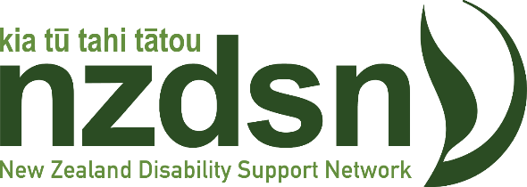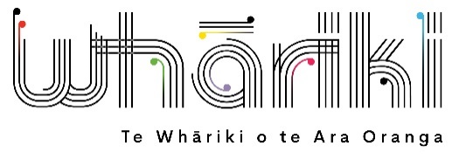
This series of three, two-hour online workshops are designed for Disability Support Services and health leaders to enhance their support of the mental health and wellbeing of autistic people, individuals with intellectual disabilities, and those with Fetal Alcohol Spectrum Disorder (FASD).

Purpose of the series
- Professional Development: Building knowledge and skills through presentations from experts who share specific tools and techniques and lead informational sessions on topics of value.
- Equitable Access to Wellbeing: Promote awareness of the framework and consider its use and implementation.
- Open Discussion: Engage in debates led by lived experience experts.
- Leadership: Challenge participants to lead and be leaders.

Goals

To influence practice and equip the health and disability workforce with the knowledge, skills, and values needed to become a respected force that supports the mental health and wellbeing of autistic people and those with intellectual disabilities, one person at a time.

Audience
These hui are open to all people working in disability support services, health, mental health, and the community.

Approach and Expectations
- Lived Experience Discussions: Led by individuals with firsthand experience (both lived experience and as clinicians).
- Online Format: Mix of professional development, expert-led discussions, and personal reflection.
- Series Commitment: Participants are encouraged to attend all three sessions for ongoing discussions and challenges, though each online seminar will have value alone.
- Knowledge Sharing: Participants to share insights with colleagues.

Session Details

Workshop 1 – Titiro whakamuri, kōkiri whakamua (looking back to move forwards): Autism trends and potential - 22 August with Altogether Autism

Where: Zoom
When: 22 August 2024, 10am to noon

Register for the 22 August Autism Trends and Potential workshop here!

Presenters: Marina Elisara - Independent, neuro-affirming Mental Health Occupational Therapist, Catherine Trezona - Altogether Autism National manager, Rachael Wiltshire - Altogether Autism live chat agent and researcher, John Vogenthaler - programme lead and principal advisor – disability at Te Pou

Description:

- Review a decade of disability support services for Autistic people.
- Reflect on the current state.
- Reset our thinking on future service provision for neurodivergent communities.

Outcomes:

- A clear picture of the past decade of support services for Autistic people.
- A thoughtful look at the current state of these services, highlighting what's working and what needs change.
- Fresh ideas and plans for improving future services for neurodivergent communities.

Structure:
- Presentations, Polls, facilitated discussions (break out groups), Q&A, Panel

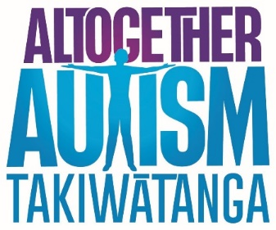

Workshop 2 - Positive Behaviour Support (PBS)

Where: Zoom
When: 19 September, 10am to noon

Register for the 19 September PBS workshop here!

Presenters: Willem de Vocht - Senior lead for PBS at Explore Hapainga Ora, John Vogenthaler - Programme lead and principal advisor disability at Te Pou and others

Reflection: Positive Behaviour Support (PBS) is woven through the Equitable Access to Wellbeing framework. Linking the delivery of PBS to the framework is strategic, as PBS is highly valued by the sector and delivers strong benefits, particularly in the support of people with high and complex needs.

Outcomes:

- Increase awareness of PBS.
- Demonstrate the use and effectiveness of PBS across various settings.
- Promote PBS training.

Initial ideas:

- Defining PBS - Introduction to the concept and principles.
- British Institute of Learning Disabilities (BILD) PBS Resources - Overview of relevant webinars and tools.
- Case Studies - Examples of PBS implementation in organisations, such as hospitals.
- Career Force: Description and promotion of their Level 5 qualification in PBS.

Structure:
- Presentations, Polls, facilitated discussions (break out groups), Q&A, Panel



Workshop 3 – Fetal Alcohol Spectrum Disorder (FASD), the hidden disability: Building Skills and Professional Development for the Disability and Mental Health Workforces
Where: Zoom
When: 14 November, 10am to noon

Register for the FASD skills workshop here!
Presenters: Kim Milne Principal Advisor (FASD-CAN), Dr Leigh Henderson Chair – (FASD-CAN), John Vogenthaler programme lead and principal advisor disability (Te Pou)
Fetal Alcohol Spectrum Disorder (FASD) is a brain and body-based disability that can affect people prenatally exposed to alcohol. It is a lifelong disability that impacts each person uniquely. People with FASD will have differing degrees of challenges in their daily lives that require understanding, support and accommodation to enable them to lead their best lives. Addressing this requires frontline workers to upskill on understanding FASD and developing approaches to interact with and support people with FASD. Good support minimizes the risk of secondary effects of poor mental health and addiction.
This interactive Workshop will enable leaders in the disability and mental health workforce to understand the need for specialised knowledge about FASD, consider support needs within their sector and identify best-practice approaches and strategies that can be used to help FASD individuals achieve healthy life outcomes. Attendees will hear from individuals with FASD and their caregivers on their experiences in interacting with professionals and can consider how these impact on their own workforce development.
Workshop Learning Aim:
To assist leaders in the disability and mental health sectors to identify professional development needs and appropriate strategies to enable them to support people with FASD.
Outcomes of this workshop:
- Gain an understanding of Fetal Alcohol Spectrum Disorder (FASD) and how the symptoms of this neurodisability impact the body, brain, learning, and behaviour of individuals with FASD.
- Develop an awareness of best practices from the lived-experience perspective to support the wellbeing of those with FASD.
- Recognise the importance of upskilling the workforce to effectively support this common and complex neurodisability.
- Identify the necessary workforce skills and other factors to consider when supporting and interacting with FASD clients.
- Identify key issues to raise and discuss within their service and work team to improve the support provided to FASD clients.
Image:
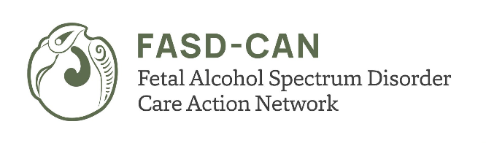
Web page:
Fetal Alcohol Spectrum Disorder - Care Action Network (fasd-can.org.nz)

